Azure API Management

High Level Design

v0.5 (DRAFT)

Contents
1. Document Control 7
1.1. Document History 7
1.2. Document Authors 7
1.3. Assurance 7
1.4. Document References 8
1.5. Definitions 8
2. Executive Summary 9
2.1. Purpose 9
2.2. Context 9
2.3. Scope 9
2.4. Out of Scope 9
2.5. Audience 9
2.6. Proposed Solution 10
3. Requirements 11
3.1. Source Requirements 11
3.2. Requirements Traceability 11
3.3. Architecture Principles 11
3.4. Non-Functional Requirements 12
4. Architecture Decisions 13
5. Target Architecture 15
5.1. High-Level Architecture 15
5.2. Logical Architecture 16
5.3. Access and Security Boundary 17
5.4. Deployment Architecture 17
6. API Access and Edge Security 19
6.1. API Users 19
6.2. Internal Access 19
6.3. External/Partner Access 19
6.4. DNS and Custom Domains 19
6.5. Edge Controls 19
7. Network Connectivity Architecture 23
7.1. Network Context 23
7.2. Traffic Flows 23
8. Security and Identity Architecture 25
8.1. Security Model 25
8.2. Authentication & Role Based Authorization 27
8.3. Secrets and Certificates 28
8.4. Data Classification and Logging 28
9. Developer Portal 29
9.1. Reference Architecture 29
9.2. Access Model 30
9.3. Deployment and Hosting 31
9.4. Content and Promotion 31
9.5. Internal Onboarding 32
9.6. Partner Onboarding 32
9.7. Security Controls 33
10. API Design, Policies and Lifecycle 34
10.1. Governance Model 34
10.2. Policy Hierarchy 35
10.3. APIM Policy Standards 35
10.4. Lifecycle and Versioning 35
11. Environments and APIOps 36
11.1. Environment Model 36
11.2. APIOps 36
12. Component Configuration 38
13. Reliability and Backup Strategy 39
13.1. Resilience 39
13.2. Deployment-Unit Implication 39
13.3. Backup, Restore and Rebuild 39
13.4. RTO and RPO 39
14. Observability and Operational Management 40
14.1. Monitoring Architecture 40
14.2. Telemetry 40
14.3. Dashboards and Alerts 41
15. Capacity and Cost 42
15.1. Capacity 42
15.2. Cost Drivers 43
15.3. Cost Controls 43
16. Operating Model 44
16.1. Ownership 44
16.2. Existing Processes 45
17. Architecture Impact Assessment 46
17.1. High Level Impact Assessment 46
17.2. Business Architecture 46
17.3. Application Architecture 46
17.4. Data Architecture 46
17.5. Technology Architecture 46
17.6. Security Architecture 47
17.7. Service Architecture 47
18. RAID 48
18.1. Risks 48
18.2. Assumptions 48
18.3. Issues 49
18.4. Dependencies 49
19. Appendices 50
19.1. Microsoft WAF Alignment 50
19.2. Architecture Decisions Explained 51
19.2.1. Edge Service Components (ADR-01) 51
19.2.2. APIM Premium v2 (ADR-02) 52
19.2.3. APIM Network Model (ADR-03) 52
19.2.4. Resilience Tiers (ADR-09) 53
19.2.5. Developer Portal Hosting (ADR-10) 55
19.3. Platform Implementation Stages 56
19.4. Operational Readiness Criteria 57
19.5. Microsoft References 58

Document Control

Document History
Version | Date | Author | Notes
0.1 | 21/09/2026 | Puneet Kumar | Initial draft restructured to the Organization’s HLD template
0.2 | 29/09/2026 | Puneet Kumar | Updated RBAC model, enhanced Developer Portal architecture, refined API publishing approach, and incorporated Microsoft design references and best practices.
0.3 | 02/10/2026 | Puneet Kumar | Added Azure Policy requirements, governance controls, security baselines, and Landing Zone alignment considerations.
0.4 | 07/10/2026 | Joycell Sundararaj | Refined API platform architecture, integration and connectivity patterns, APIOps deployment approach following stakeholder walkthrough.
0.5 | 12/10/2026 | Binila Elsa Joy | Incorporated architecture review feedback, including API testing strategy and standards, change governance requirements, DNS and networking updates, policy enhancements, SSL certificate lifecycle guidance, and architecture impact, complexity and strategic alignment assessments.

Document Authors
Role | Name | Title
Author | Puneet Kumar | Consulting Integration Architect
Contributor | Nikhil Rokade | Portfolio Architect
Author | Joycell Sundararaj | Integration Architect
Contributor | Phanindra Nizalapuram | Integration Architect
Contributor | Binila Elsa Joy | Integration Lead

Assurance
This document has been reviewed and approved by the following, the list has been grouped into different sections to aid readability as this document will be required at TDA.

Role | Description
Information | Shared for informational purposes including use as reference document for their domain’s documentation and processes
Reviewer | Actively reviews the content to ensure alignment to guidelines and policies and technical accuracy, will contribute as required
Approver | Provides assurance that their domain is correct in context of the HLSA

Role | Name | Title
Reviewer | Kosta Konstantinov | Enterprise Architect
Reviewer | Steve Coldwell | CTO
Reviewer | Chad Ozdil | Security Architect
Reviewer | Jamie Barclay | Cloud Architect
Information | Diana Constable | Head of Engineering

Document References
The following documents should be read in conjunction with this document:

Reference | Document
1. | Parameter sheets
2. | Security Principles
3. | Cloud Security Framework
4. | APIM Policy Capability Matrix
5. | API Life cycle
6. | Enterprise DevOps Principles
7. | Engineering principles

Definitions
The terms below are used throughout this document.
Term | Meaning
APIM | Azure API Management, the managed API gateway service
WAF | Web Application Firewall
Entra ID | Microsoft Entra ID, the identity provider (formerly Azure AD)
NVA | Network Virtual Appliance, here the Palo Alto firewall
APIOps | Managing APIM configuration as code through a CI/CD pipeline
RTO / RPO | Recovery Time / Point Objective
mTLS | Mutual TLS
SIF | Systems Integration Framework, the client’s integration reference document
RACI | Responsible, Accountable, Consulted, Informed, a responsibility model
BOLA | Broken Object-Level Authorization, an OWASP API risk
DNAT / SNAT | Destination / Source Network Address Translation
IPAM | IP Address Management
SIEM | Security Information and Event Management
JWT | JSON Web Token
DDoS | Distributed Denial of Service
VNet | Azure Virtual Network
Private Link | Private connectivity to an Azure service over the Microsoft backbone

Executive Summary

Purpose
This HLD defines the proposed target architecture and governing decisions for the Chaucer APIM platform. It covers platform positioning, internal and external API access, developer portal, edge security, identity, networking, governance, delivery, observability, resilience, capacity and service-readiness requirements.

Context
Chaucer does not currently operate a dedicated API management platform. Existing API exposure and consumption use point-to-point integrations, file exchanges and direct connections, limiting standardisation, visibility and reuse.

APIM is intended to add a central API layer for security, governance, monitoring and access management while complementing the existing integration estate. The SIF requests actionable architecture and governance guidance based on service-oriented architecture, reusable business-capability-aligned services and Azure PaaS. It positions APIM as the single API entry point and explicitly does not seek a general microservices architecture.

Scope
This HLD includes:
- APIM platform role and target architecture
- Developer portal and API discovery
- Internal, partner and external API access
- Azure Front Door and WAF edge controls
- Private, hybrid and public SaaS connectivity
- Identity, authentication, authorization context and secrets
- Products, subscriptions, groups and onboarding
- API policy, lifecycle and versioning guardrails
- Environments, APIOps and release controls
- Observability and operational telemetry
- High availability, recovery, capacity and cost
- Governance, assumptions, risks, dependencies

Out of Scope
The following are explicitly outside the scope of this High-Level Design and will be addressed through separate design, engineering or operational activities:
- Detailed backend and application design. The internal design, data models and integration logic of the backend systems exposed through APIM.
- Individual API specifications. The detailed OpenAPI contract, request/response schema and policy configuration for each specific API, which are delivered per API during onboarding.
- Device-level network configuration. The specific rule configuration of the central firewall, routers and other network appliances, which remains with the network team.
- Identity platform design. The design of Microsoft Entra ID itself, tenant configuration and the broader identity estate, which APIM consumes as an existing service.

Audience
This document is intended for the Chaucer Technical Design Authority, enterprise and solution architects, and the platform, networking, security and integration teams who will build and operate the platform. It assumes familiarity with Azure and with enterprise integration concepts.

Proposed Solution
Adopt Azure API Management (APIM) Premium v2 as the strategic API gateway for Production and UAT environments, with Azure Front Door Premium and Web Application Firewall (WAF) providing the external ingress layer. Standardise on Microsoft Entra ID and OAuth 2.0 for API consumer authentication, Azure Key Vault for certificate and secret management, APIM Developer Portal as the standard API discovery and onboarding experience, and Terraform, Azure Repos, and Azure DevOps Pipelines for automated platform and API delivery conforming to the Microsoft Well-Architected Framework.

Requirements

Source Requirements
The requirements for the APIM platform are drawn from the Chaucer Systems Integration Framework (SIF) and the agreed scope for enterprise API management. They cover the secure exposure and consumption of APIs by internal and external consumers, authentication through Microsoft Entra ID and OAuth 2.0, protection of API endpoints from common web and API threats, high availability and business continuity, observability, and cost-effective but segregated environments to support release management.
Each source requirement is traced to the section of this document where it is designed and addressed in the Requirements Traceability matrix that follows.

Requirements Traceability
Chaucer's stated high-level requirements for the APIM platform, drawn from the Systems Integration Framework and the agreed scope, are traced below to the section of this HLD where each is designed and addressed.
Ref | Requirement (from the SIF and Chaucer’s stated scope) | Primarily addressed in
R1 | Enable API discovery and consumption by internal and external users | Section 9
R2 | Provide secure access to services exposed by the API | Section 8
R3 | Authentication approach (Azure Entra ID / OAuth 2.0) | Section 8.2
R4 | Allow controlled access to APIs from Chaucer private and public endpoints | Section 6.2, Section 6.3, Section 7
R5 | Provide access to backend APIs from Chaucer networks (Azure VNet, Azure PaaS, public SaaS) | Section 7
R6 | Protect API endpoints from common web and API hacking techniques, like DDoS and OWASP Top 10 | Section 6.5, Section 8.1
R7 | Provide a robust service with High Availability | Section 13.1
R8 | Provide backup and disaster recovery | Section 13.3, Section 13.4
R9 | Detail HLD-relevant versioning and lifecycle | Section 10.4
R10 | Detail HLD-relevant observability and policies | Section 14, Section 10.3, Section 10.4
R11 | Traffic Manager concepts and supporting components | Section 6.5
R12 | Cost-effective but segregated environments to support release management (Prod/UAT/Dev) | Section 11

Architecture Principles
The following principles guide the design decisions recorded in this document and are derived from [Ref 7] and [Ref 3]
- Secure and private by default. APIM has no public endpoint; every API is private and unauthenticated until explicitly published and approved.
- Single governed entry point. All managed APIs are exposed and mediated through APIM; direct backend exposure and informal bypasses are not permitted.
- Zero Trust. Every call is authenticated and authorized at the gateway regardless of its network origin; internal traffic is never implicitly trusted.
- Everything as code. Platform and API configuration is version-controlled, peer-reviewed and deployed exclusively through automated pipelines.
- Cost proportionate to criticality. Resilience and capacity are tiered to business need rather than applied uniformly across the estate.
- Alignment to Microsoft guidance. The design follows Microsoft's published reference architectures and the Azure Well-Architected Framework.

Non-Functional Requirements
Detailed non-functional requirements are maintained in the NFR Specification and should be read alongside this HLD. The architecture described in this document is designed to satisfy those requirements within the capabilities of the selected Azure services.
NFR Template

Architecture Decisions
The table below summarises the architecture decisions recorded in this section. Each decision is described in full in the subsections that follow; the options comparisons behind the edge service, APIM tier and network model decisions are provided in Appendix 18.2.
ID | Area | Decision | Rationale
ADR-01 | Edge Service | Azure Front Door Premium with WAF is the selected edge entry point, over Application Gateway v2 and over a combined Front Door + Application Gateway topology. | See Appendix 18.2 (Architecture Decisions Explained) for the full options comparison.
ADR-02 | APIM Tier | Azure API Management Premium v2 is the platform tier, over the Developer, Standard v2 and Classic Premium tiers. | See Appendix 18.2 (Architecture Decisions Explained) for the full options comparison.
ADR-03 | Network Model | APIM is deployed in internal VNet (injection) mode with no public endpoint; ingress is via Front Door over Private Link and backends are reached over private routing. | See Appendix 18.2 (Architecture Decisions Explained) for the full options comparison.
ADR-04 | Access Paths | Internal and external consumers reach the same internal-mode instance through separate access paths - external via Front Door over Private Link, internal direct over the private network. | One gateway and one backend estate keep policy and governance consistent, while the entry point and authentication differ by whether the caller is inside or outside the network boundary.
ADR-05 | Identity | Microsoft Entra ID is the single identity provider and OAuth 2.0 is the default authentication standard; tokens are validated at the gateway on every call. | A single identity provider for consumers and administrators simplifies governance, lifecycle and access review. Partners unable to support OAuth 2.0 may use an approved, time-bound exception with compensating controls.
ADR-06 | Secrets and Certificates | APIM uses a managed identity to retrieve secrets and certificates from Azure Key Vault at runtime, rather than storing credentials in policy configuration. | Runtime retrieval from Key Vault removes stored secrets from the platform entirely and supports automatic certificate rotation without redeployment.
ADR-07 | API Governance | API governance is implemented initially through products, Entra ID groups and subscriptions. | Products, groups and subscriptions provide sufficient access control and consumer segmentation for the initial platform, while deferring workspaces avoids complexity until decentralised team-based ownership is required.
ADR-08 | Resilience | Production is deployed on the Silver resilience tier a single region with multiple units distributed across Availability Zones. | See Appendix 18.2 (Architecture Decisions Explained) for the full options comparison
ADR-09 | API Discovery | Use the inbuilt Azure API Management Developer Portal as the self-service interface for discovery, documentation, testing and subscription management, instead of Azure API Centre. User authentication will be provided through Microsoft Entra ID. Entra External ID/B2B remains a future capability subject to approved design and governance processes. | The APIM Developer Portal provides self-service API discovery, documentation, testing, and subscription management, whereas Azure API Centre is primarily focused on API governance and cataloguing. This reduces onboarding effort and support overhead.
ADR-10 | Developer Portal Hosting | Use the Microsoft-managed APIM Developer Portal for the initial platform implementation. Access to the portal will be restricted through Microsoft Entra ID authentication, group-based access controls and Conditional Access policies. Self-hosting remains a future option should requirements emerge that cannot be met by the managed service. | The Microsoft-managed Developer Portal minimises infrastructure, operational and maintenance overhead while meeting current security requirements. Although the portal is publicly reachable, access is restricted through Entra ID and Conditional Access controls approved by Security Architecture and Security Engineering. Self-hosting would introduce additional build, deployment and support responsibilities without a current business or security requirement.  See Appendix 18.2 (Architecture Decisions Explained) for the full options comparison
ADR-11 | API Exposure Strategy | The current APIM design supports internal API consumption only. No APIs are exposed externally, and public access is disabled by default, including Developer Portal access and API Gateway exposure through Azure Front Door. Azure Front Door will be deployed and validated during implementation but will remain inactive unless an approved business use case for external access is agreed at which point in time this architecture will be reviewed and submitted again to TDA. | This design aligns with current business requirements and security assumptions. Any future requirement for external API exposure will trigger a renewed security, technology, and architectural assessment before implementation.
ADR-12 | TLS Certificate Management | Azure Front Door managed certificates will be used for all approved custom domains. Microsoft will automatically manage certificate issuance, renewal and rollover. Azure Front Door supports certificate replacement without service interruption, removing the need for manual certificate deployment or restarts. This applies to public-facing Azure Front Door custom domains; backend/origin certificates remain independently managed as part of the end-to-end TLS architecture. | Industry certificate validity periods continue to reduce, increasing operational overhead and renewal frequency. Using Azure Front Door managed certificates reduces operational risk, supports automated certificate lifecycle management, and avoids service disruption during certificate renewals. This aligns with the cloud-native operational model and minimises dependency on external certificate management processes. Internal/backend certificate requirements, including any traffic inspection or firewall decryption requirements, continue to be managed independently. (Microsoft-reference)

Target Architecture

High-Level Architecture
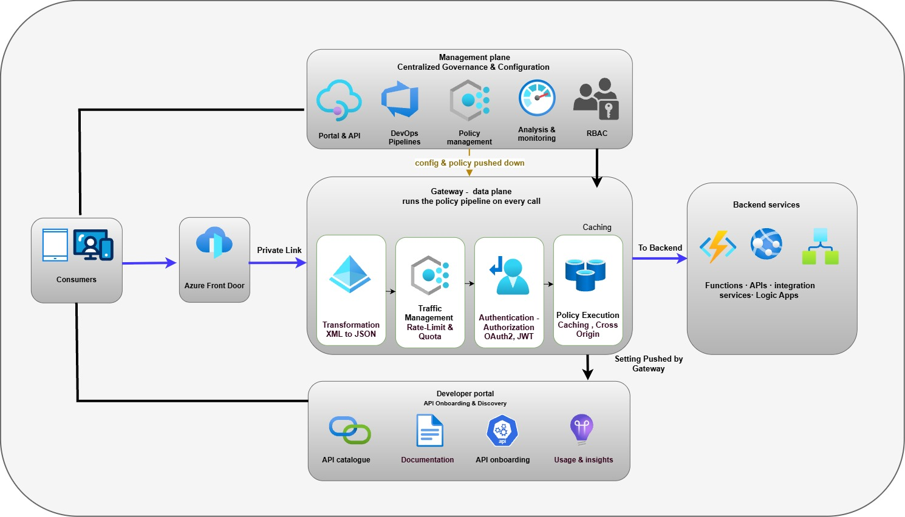

The Architecture has these parts:
- Edge Service (Azure Front Door). The internet-facing entry point into the platform. It provides global routing, Web Application Firewall (WAF) protection, TLS termination, edge-based security controls and traffic management before requests are forwarded to APIM. It also provides health probing and supports future multi-region failover scenarios.
- Gateway (Data plane). The engine that manages live traffic. API calls pass through it and it applies the same set of controls, including authentication, rate limiting, validation, routing, transformation and logging. This is where the platform processes API requests.
- Management plane. The administrative layer used to configure and govern the platform. Teams define APIs, products, subscriptions, policies and operational settings here, which are subsequently deployed to the gateway. It is used to manage the platform rather than to process runtime traffic.
- Developer portal. The self-service interface through which consumers discover APIs, access documentation, request subscriptions and manage API consumption.
- Backend Services. The systems that provide the business functionality exposed through APIs and process requests. These may include business applications, integration platforms, Azure services, and third-party SaaS solutions. APIM routes requests to the appropriate backend service after applying security, policy, and governance controls, providing a consistent and controlled access layer regardless of where the underlying capability resides.
Within the Chaucer Systems Integration Framework, APIM is the managed API layer that sits in front of the existing integration estate. It does not replace the messaging, file-based or event integration patterns described in the SIF, it adds a standardised, governed entry point specifically for API-based (synchronous, request/response) integration.
Existing integration services continue to operate unchanged. APIM provides consistent security, policy enforcement, observability and access management for the APIs exposed through it, complementing the broader integration landscape rather than consolidating it.

Landing zone Architecture
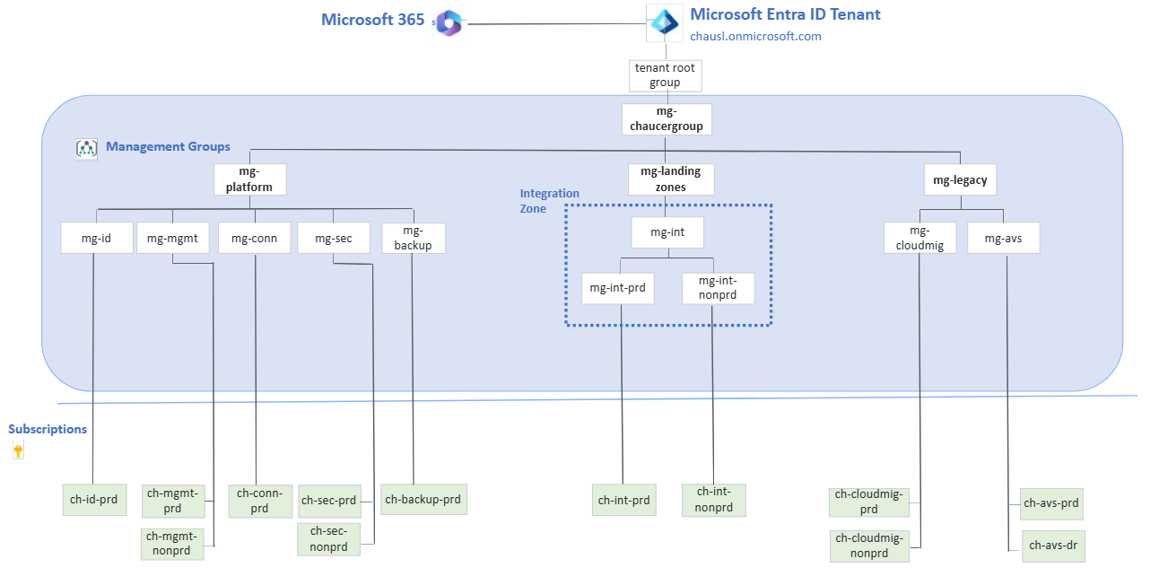
The APIM platform is hosted within Chaucer's Azure Landing Zone architecture, providing centrally managed governance, security, networking and operational services. Resources are deployed in dedicated Integration landing zone subscriptions, with separate production and non-production environments to ensure environment segregation, governance compliance and controlled change management.

Logical Architecture
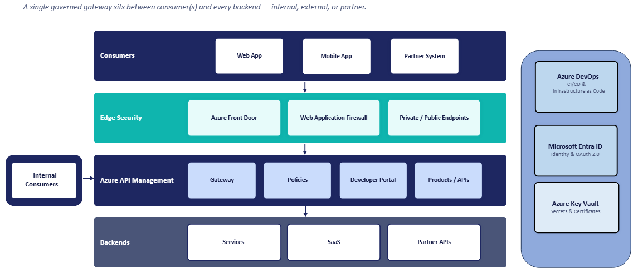

Component | Responsibility
Azure Front Door Premium | External HTTP routing, WAF, TLS and origin health
APIM Gateway | Runtime authentication, policy, throttling, routing and telemetry
APIM Management Plane | API, product, policy and platform administration
Developer Portal | Discovery, documentation and subscription management
Entra ID | Consumer, application and administrative identity
Key Vault | Secrets, signing material and certificates
Azure Monitor services | Logs, metrics, traces, dashboards and alerts
Backend Services | Business processing and domain-specific authorization
Azure DevOps | Source control, validation, approval and deployment

Access and Security Boundary
All requests are processed by the same Azure API Management instance, but the path differs depending on where the consumer is located. External consumers enter through Azure Front Door and cross the internet boundary once, while internal consumers access APIM directly from within the corporate network and remain on private connectivity throughout.
There are two main access paths as detailed below:
External path: A public client or partner reaches Azure Front Door with WAF, which terminates TLS and applies OWASP protection at the edge before anything reaches APIM. The call then travels over Private Link to APIM, which validates the OAuth 2.0 token before forwarding it to the backend.
Internal path: An internal application calls APIM directly over the private VNet, with no edge service in the path because there is no public exposure to guard against. APIM authenticates the caller against Microsoft Entra ID, then routes the request to the target backend.
Both paths terminate at the same internal-mode gateway and the same backend estate; only the entry point and the authentication mechanism differ.
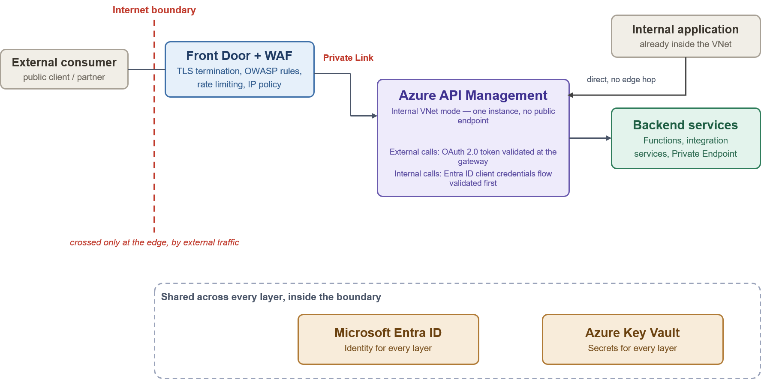

Deployment Architecture
APIM is deployed in internal VNet-injection mode on the Premium v2 tier, within a dedicated delegated subnet. It has no public data-plane endpoint; inbound external traffic arrives only through Azure Front Door over a Private Link private endpoint, and internal traffic arrives over private network connectivity.
Production is deployed zone-redundant across Availability Zones (the Silver tier). The platform is provisioned and updated exclusively through infrastructure-as-code and APIOps pipelines, so its deployed configuration is reproducible and auditable. The concrete instance composition and network topology are detailed in Section 7 and the appendices.
Below is the deployment architecture (Source)

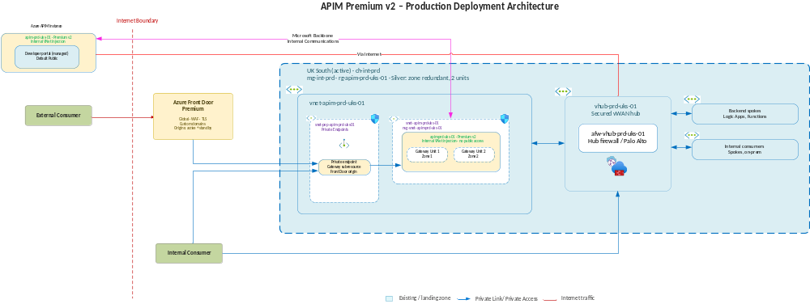

API Access and Edge Security

API Users
APIs exposed through the platform serve distinct audience classes, each with a different access path and authentication expectation:
- Internal consumers. Chaucer applications and services, and on-premises systems reaching Azure over private connectivity, calling internal APIs from within the network boundary.
- External partners (B2B). Known partner organisations brokers, market participants, suppliers and service providers represented through Microsoft Entra External ID (B2B) with partner-specific application registrations.
- Public or third-party clients. External clients reaching published APIs through the inspected edge, subject to WAF, OAuth 2.0 and per-subscription rate limits and quotas.
Access, visibility and policy are governed per audience class through products, subscriptions and Entra ID groups, as detailed in Section 9.

Internal Access
Internal consumers call APIM directly over the private network via VNet peering, or over ExpressRoute or VPN for on-premises systems with no edge service in the path, because there is no public exposure to guard against on this route.
Internal traffic remains on the organisational network and is routed through the central firewall in accordance with the networking model. Internal consumers never bypass APIM; every request is authenticated through Microsoft Entra ID and evaluated against platform policies in line with the Zero Trust security model.

External/Partner Access
External consumers access the platform through Azure Front Door with WAF, which provides TLS termination, OWASP protection and DDoS mitigation before requests are forwarded to APIM over Private Link. As APIM is deployed in internal mode, it is not directly accessible from the internet. At the gateway, OAuth 2.0 tokens are validated, and subscription-based quotas and rate limits are enforced before requests are routed to the appropriate backend service.

DNS and Custom Domains
External API and developer portal endpoints are published on Chaucer custom domains presented at Azure Front Door with TLS certificates managed through the edge. Chaucer currently uses ADDS for internal DNS resolution. Azure Private DNS zones will be created to support Azure Private Endpoint dependencies however ADDS remains the authoritative internal DNS service and will continue to provide name resolution for internal consumers.

Edge Controls
The table below summarises the controls applied at the Azure Front Door Premium edge before external traffic reaches APIM.
The last column identifies whether the control is inherited from the platform or configured for this design, and where the associated parameter is recorded.
- Inherited. Built into Front Door Premium. Nothing is set per deployment other than choosing the Premium tier.
- Configured. A setting chosen for this design and recorded as a parameter, in the APIM Setup Parameter Sheet (Edge Service Config tab, shown as “Parameter Sheet”) or the APIM Resources Sheet (Front Door tab, shown as “Resources Sheet”).
- Inherited + Configured. The platform provides the capability, and a parameter sets how it behaves.

Control | Purpose | Implementation | Applies To | Inherited or Configured
Web Application Firewall (managed rules) | Detects and blocks common web attacks, including SQL injection and cross-site scripting (OWASP Top 10 categories). | A WAF policy is attached to the Front Door profile with the Microsoft Default Rule Set enabled. It runs in Prevention mode, so matching requests are blocked rather than logged. | Front Door edge, on every route, before traffic is forwarded to APIM. | Inherited + Configured.  The WAF engine and rule content come with Front Door Premium; the rule set and mode are parameters. Parameter Sheet: WAF policy mode; Managed rule set.
Bot protection | Detects and blocks malicious automated traffic using Microsoft's bot intelligence. | The Microsoft Bot Manager Rule Set is enabled in the same WAF policy and acts according to the policy's Prevention mode. | Front Door edge (same WAF policy). | Inherited + Configured.  Bot intelligence comes with Front Door Premium; enabling the rule set is a parameter. Bot protection helps identify and mitigate crawler and bot traffic. Monitor trends to manage traffic growth and consumption.  Parameter Sheet: Bot protection rule set.
Rate limiting | Limits requests from a single client to reduce abuse, scraping and brute-force attacks. | WAF custom rules count requests per client IP address over a one-minute window and block requests above the threshold: 300 per minute for general API traffic, 15 per minute for sensitive or authentication endpoints. | Front Door edge. Finer per-subscription limits are applied separately at the APIM gateway. | Configured. Initial rate-limit thresholds are defined to provide a reasonable security baseline from day one.  Thresholds are starting values and are tuned against real traffic. Parameter Sheet: Rate limit threshold (general API traffic); Rate limit threshold (sensitive/auth endpoints); Rate limit window.
DDoS mitigation | Protects against network and protocol-based denial-of-service attacks. | Protection against network-level DDoS attacks is built into Front Door's global edge network. Application-layer attacks are further constrained by the WAF and rate-limiting controls. | Front Door edge, before traffic reaches Chaucer's network. | Inherited.  Nothing is set per deployment.
TLS termination and HTTPS enforcement | Encrypts traffic in transit. Front Door terminates TLS at the edge for inspection and re-encrypts traffic before forwarding it to APIM. | HTTPS is required on every custom domain. TLS 1.3 is the preferred protocol version, with TLS 1.2 retained for compatibility with consumers that cannot yet support TLS 1.3.  . HTTP requests are redirected to HTTPS and forwarded to APIM over HTTPS only. The certificate is Azure-managed. | Front Door edge (client to Front Door) and Front Door routes (Front Door to APIM). APIM's TLS minimum is configured separately. | Inherited + Configured.  TLS termination and managed certificates come with Front Door; the version, certificate source and route protocol are parameters. Parameter Sheet: TLS minimum version; Custom domain certificate. Resources Sheet (Front Door Routes): Forwarding Protocol; HTTPS Redirect.
Private Link origin | Provides private connectivity between Front Door and the APIM gateway, removing the need for direct public gateway access. Supported with a VNet-injected Premium v2 instance when fronted by Front Door Premium. | The Front Door origin is created as type API Management with the Gateway Private Link sub-resource. Front Door sends a private endpoint connection request, which an APIM owner approves as a one-time deployment step. | Between Front Door and the APIM gateway endpoint. | Configured. Parameter Sheet: Origin type. Resources Sheet (Front Door Origins): Private Link Target and Sub-resource.
Caching | Stores responses at the edge to improve response times for repeat requests. | Caching is disabled on API routes by default because responses are dynamic and often consumer specific. It may be enabled for individual routes that serve cacheable GET responses. | Front Door routes. | Configured (off by default). Parameter Sheet: Caching.
Origin health probes | Monitors APIM gateway health to ensure traffic is sent only to healthy origins. | The gateway origin group probes APIM's status endpoint over HTTPS every 30 seconds and treats the origin as healthy when 3 of the last 4 probes succeed. | Front Door origin group for the APIM gateway. | Configured. Parameter Sheet: Origin health probe path; Origin health probe protocol / interval. Resources Sheet (Front Door Origin Groups).

Points to note:
- Geo-filtering. Allowing or blocking requests by client country is available as a WAF rule but is not enabled by default. It would be enabled only if data-residency or partner-geography rules require it (Parameter Sheet: Geo-filtering).
- DDoS protection on the hub. Azure DDoS Network Protection on the hub VNet (Parameter Sheet: DDoS protection) is a separate control. It protects public IP addresses hosted in the hub; it does not sit on the Front Door inbound path, which is covered by the edge protection above.
- Mutual TLS. Front Door ends TLS at the edge. Microsoft currently documents client-certificate (mutual TLS) authentication on Front Door as a preview capability, so this design does not assume it is available at the edge.
- Developer portal. Private Link applies to the APIM gateway endpoint only; Microsoft supports inbound Private Link for the Gateway sub-resource only. Making the developer portal available to external users is therefore not provided by this control and is a separate design decision.
- Tuning. Rate-limit thresholds are indicative starting values and are tuned against real traffic.

Network Connectivity Architecture

Network Context
APIM is deployed within the Chaucer landing-zone architecture and relies on private DNS, hybrid connectivity and centralised network security controls. The HLD defines the required connectivity patterns; route tables, address allocations, firewall policies and DNS records are maintained separately within the parameter sheets. [Ref 1]

Network routing follows the Chaucer networking model, with Azure Routing Intent directing traffic through the central Palo Alto inspection layer where applicable.

Traffic Flows
This subsection elaborates the four main traffic flows possible.
Flow 1: External to APIM
An external consumer accesses an API through Azure Front Door. Traffic is inspected at the edge using WAF, TLS termination and DDoS protection before being forwarded to APIM over Private Link. As APIM is deployed in internal mode, it is not directly accessible from the internet.
- Front Door provides WAF protection, TLS termination and DDoS mitigation.
- APIM accepts traffic only from the approved Front Door Private Link origin and applies authentication, authorisation and gateway policies.
- Network Path: Traffic remains on the Microsoft backbone between Front Door and APIM and does not traverse the Palo Alto firewall.
Flow 2: Internal to APIM
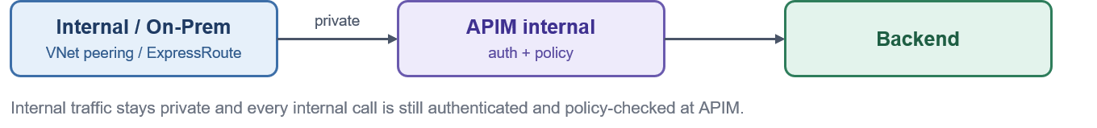
An internal Chaucer system, or an on-premises system connected through ExpressRoute or VPN, calls an internal API through APIM. Requests reach the gateway through private network connectivity, where authentication, authorization and policy controls are applied before routing to the target backend service.
Traffic from internal consumers to the APIM gateway remains on the private network and is routed through the central Palo Alto firewall in accordance with the networking model. Internal consumers never bypass APIM; every request is authenticated through Microsoft Entra ID and evaluated against platform policies in line with the Zero Trust security model.

Flow 3: APIM to External

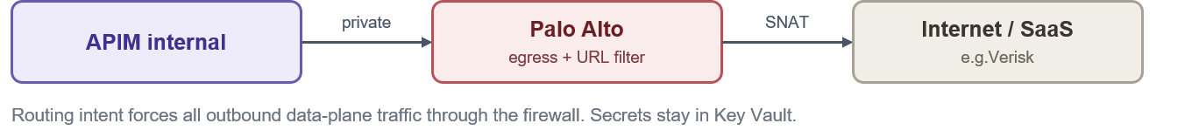
When APIM or a backend service calls an external SaaS provider or internet-facing endpoint, traffic is routed through the central egress path for inspection and control.
- Routing Intent directs outbound traffic through the central Palo Alto firewall.
- Palo Alto applies outbound security controls, URL filtering, threat prevention and logging.
- Credential Management: Secrets and credentials are retrieved from Azure Key Vault and are not stored within firewall configurations.
Flow 4: APIM to Internal

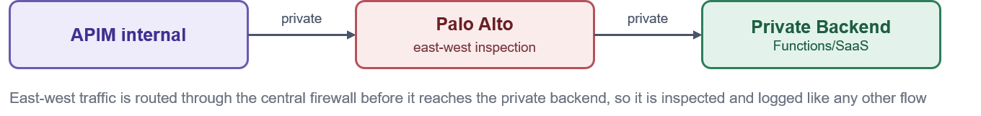
Calls from APIM to internal backends, including Azure Functions, integration services and PaaS services accessed through Private Endpoints, remain on the private network. East-west traffic is routed through the central Palo Alto firewall using Azure Routing Intent before reaching the destination service. This ensures internal platform traffic is subject to consistent inspection, policy enforcement and monitoring.

Security and Identity Architecture

Security Model
Security is the foundational principle of the platform architecture. Access is validated at every hop and never assumed based on network location or prior perimeter controls. Internal and external requests are subject to the same authentication and authorization requirements.
No individual security control is relied upon in isolation. Each request passes through a mandatory, ordered sequence of defence-in-depth controls before reaching downstream targets.
Security architecture: Gateway Ingress Defence in Depth

The diagram below illustrates the defence-in-depth model for a private APIM deployment protected by edge security controls. Requests traverse multiple security layers before reaching backend services, with each layer providing a distinct security function. Platform security is achieved through the combined operation of all controls rather than reliance on any single mechanism.
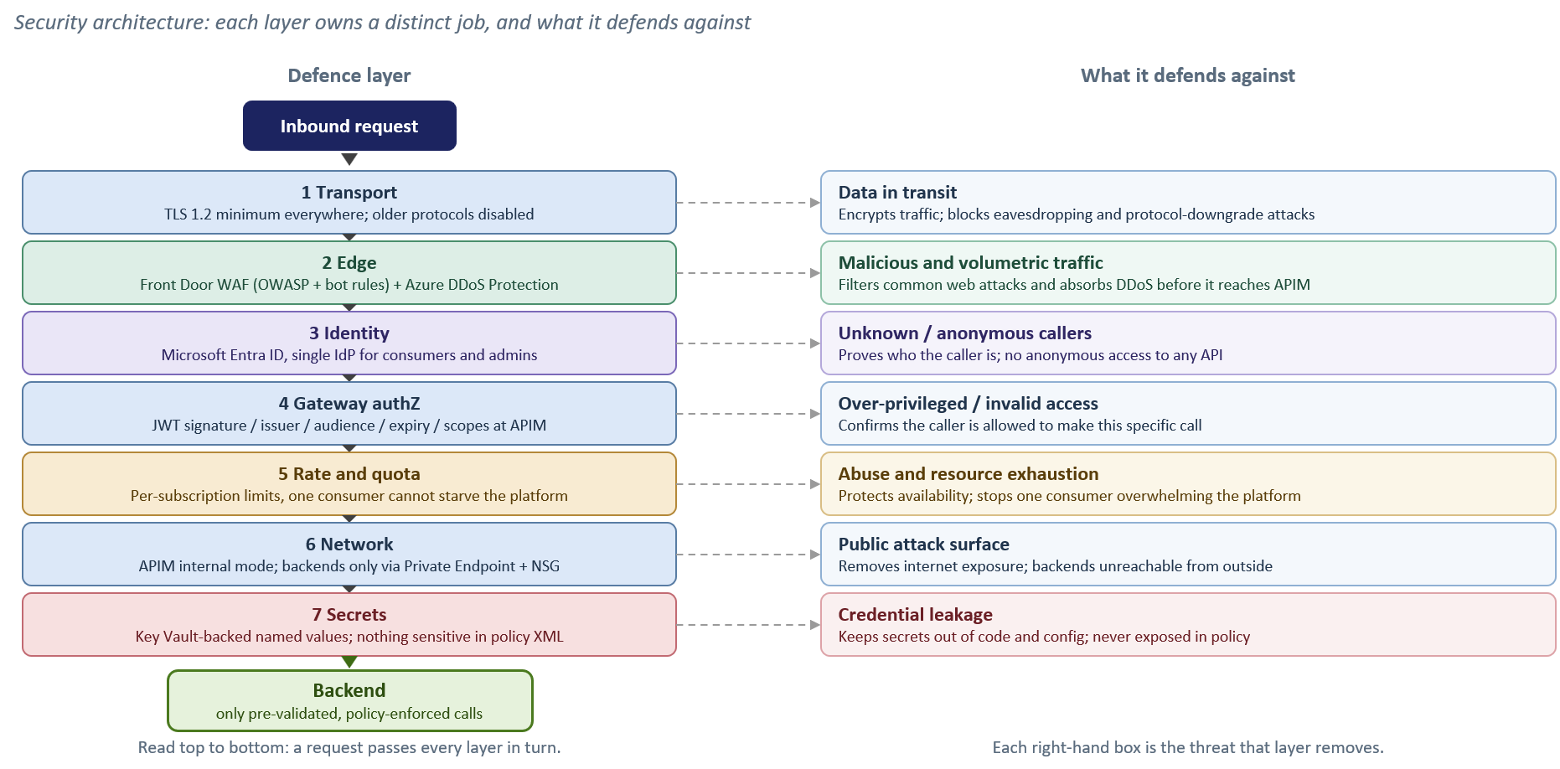

Security design principles [Ref 2] [Ref 3]
The controls detailed in this section enforce seven foundational security principles across the platform:
- Verify Explicitly (Zero-Trust): Every request is authenticated and authorized regardless of network origin.
- Defence-in-Depth: Security is provided through multiple complementary controls including WAF, gateway policies, identity validation and network isolation.
- Least Privilege: Consumers, APIOps deployment pipelines, and administrators are granted the minimum permissions necessary to perform their roles.
- Secure & Deny by Default: APIs remain inaccessible until explicitly published, secured and approved.
- Single Identity Provider: Microsoft Entra ID provides centralized identity and access management for consumers and administrators.
- Everything as Code (APIOps): Platform and API security configurations are version-controlled, peer-reviewed, and deployed exclusively via automated pipelines.
- Zero Secrets in Code: Secrets, certificates and credentials are stored outside source control and referenced securely through Azure Key Vault.
Threat model: STRIDE and the OWASP API Security Top 10
To ensure comprehensive coverage, the platform security model is evaluated against two complementary frameworks:
- STRIDE: Evaluates platform and infrastructure-level threat vectors (Spoofing, Tampering, Repudiation, Information Disclosure, Denial of Service, Elevation of Privilege).
- OWASP API Security Top 10: Addresses API-specific application vulnerabilities (BOLA, Broken Authentication, Mass Assignment, Unmanaged APIs).
Threat Vector & Key Risk Area | Framework Mapping | Architectural Control & Enforcement Strategy
Identity Spoofing & Broken Authentication | STRIDE: Spoofing  OWASP: API2:2023 | Mandatory Microsoft Entra ID OAuth 2.0 / JWT validation at gateway; strict claim inspection; mTLS and static IP allow-listing for authorized legacy exceptions. See section6 and section10.7
Data Tampering & Payload Injection | STRIDE: Tampering  OWASP: API8:2023 | Enforcement of TLS 1.2+ end-to-end; edge Azure Front Door WAF rulesets; strict OpenAPI request schema validation at gateway ingress.  See section6.5 and section10.7
Repudiation & Audit Gaps | STRIDE: Repudiation  OWASP: API10:2023 | Centralized, immutable Azure Monitor / Log Analytics audit trail for all management and control plane actions; structured APIOps deployment logging. See section11.2 and section14
Information Disclosure & Secret Exposure | STRIDE: Info Disclosure  OWASP: API3:2023 | Strict Private Endpoints / VNet isolation; zero plain-text secrets in policies (Azure Key Vault-backed Named Values); payload logging disabled by default with strict PII redaction rules section7.1 and section 8.3
Denial of Service & Resource Exhaustion | STRIDE: Denial of Service  OWASP: API4:2023 | Edge Azure DDoS Protection; per-subscription rate limits and quotas; dynamic gateway autoscaling based on CPU/Memory thresholds. section6.5 and section15
Broken Authorization (BOLA / BFLA) | STRIDE: Elevation of Privilege  OWASP: API1 & API5:2023 | Shared Responsibility Boundary: APIM validates caller identity/scopes and forwards claims. Downstream domain backends must enforce object-level and function-level authorization checks. section8.2 and section9.2
Shadow / Unmanaged API Proliferation | STRIDE: All Categories  OWASP: API9:2023 | Single ingress path via central APIM catalogue; mandatory metadata tagging (audience, lifecycle status, data sensitivity); structured APIOps deprecation pipelines. section11.2 and section 9.1

Consumer Authentication Model

Consumer | Primary Authentication Method | Secondary / Compensating Control
External partner | OAuth 2.0 token issued by Entra ID and validated at APIM. | Subscription key, IP allow-list where fixed egress IPs exist
Internal Organization system | Managed Identity | Entra ID conditional access on the calling service
Inbound Vendor Webhook | Shared secret header, checked against Key Vault | IP allow-list restricting the source range

Partner and External Identity

The Organization's external consumers include brokers, market participants, strategic partners, suppliers and third-party service providers. Authentication and onboarding approaches may vary by consumer type and technical capability.
- Preferred approach: External organizations are represented through Microsoft Entra External ID (B2B) using partner-specific application registrations and controlled access assignments.
- Approved alternatives: Where Entra-based integration is not supported, approved federated identity, OAuth 2.0, mTLS, HMAC-signed requests or other approved authentication mechanisms may be used through the exception process.
- Governance requirement: Partner onboarding, application registration, credential and certificate lifecycle management, access reviews, rotation and revocation responsibilities must be defined and owned by the appropriate Identity and Access Management function before implementation.

Authentication & Role Based Authorization
Authentication establishes who the caller is; authorization determines what they may access. Gateway-level authorization is enforced through token validation, claims evaluation and subscription controls. The validated token is inspected to confirm issuer, audience, expiry and required scopes before requests are allowed to proceed.
Access follows a secure-by-default model. APIs are not accessible until visibility has been granted through the appropriate product, group membership and subscription assignment. For detail configuration about the parameters check the reference. [Ref 1]
RBAC Model for Azure Front Door, APIM and Developer portal.
The diagram below illustrates the end-to-end Role-Based Access Control (RBAC) model for Azure API Management. User identities are authenticated through Microsoft Entra ID, with access governed using Entra ID groups, Azure RBAC roles, APIM products, and subscriptions. Internal users access APIM directly through the private network, while external users connect via Azure Front Door and WAF. Azure API Management validates authentication tokens, enforces authorization policies, and controls access to backend services and the Developer Portal based on assigned roles and group memberships.

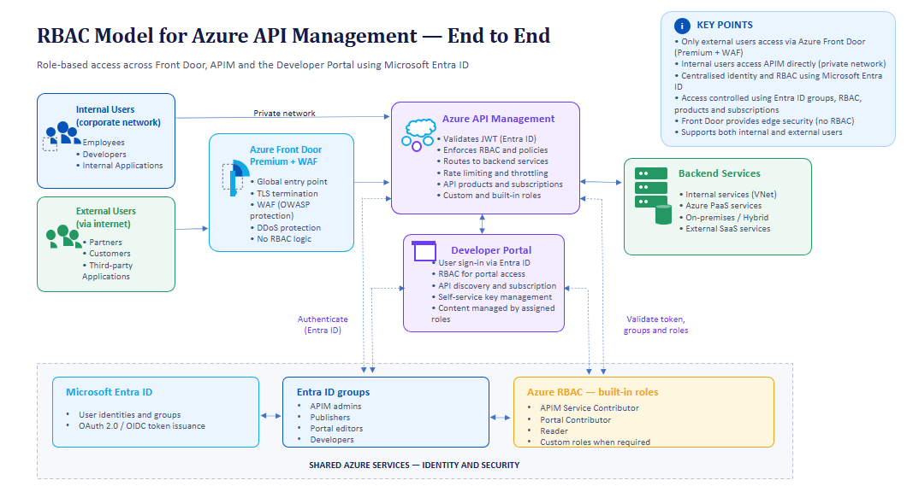

Secrets and Certificates
The preferred implementation is that APIM does not store application secrets locally. Required certificates, keys and credentials are retrieved from Azure Key Vault at runtime using the APIM managed identity.
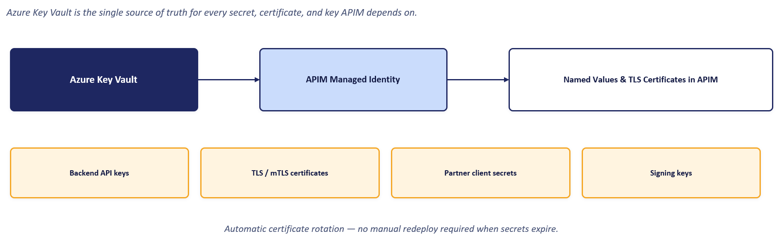

Data Classification and Logging

Principle | Design Control | APIM Enforcement
Classify at Onboarding | Every API is assigned a data classification (Public, Internal, Confidential, Restricted) during onboarding. | Classification recorded as part of the API onboarding process and used to determine logging, monitoring, and support requirements.
No Body Logging by Default | Request and response payload logging is disabled by default across the platform. | APIM diagnostics and Application Insights are configured to capture operational telemetry only. Payload logging requires documented approval and explicit configuration.
No PII in Telemetry | Sensitive data must not be written to logs, traces, or monitoring platforms. | APIM policies redact or exclude Authorization headers, subscription keys, cookies, tokens, and identified PII before telemetry is exported.
Centralised Logging Standards | Logging behaviour must be consistent across all APIs. | Shared policy fragments and platform standards enforce common telemetry, redaction, and monitoring controls.
Least-Privilege Observability | Operations teams require visibility without access to sensitive payload data. | Monitoring focuses on availability, latency, throughput, dependency failures, and error rates rather than business content.

Developer Portal

Reference Architecture
Purpose
The Azure APIM Developer Portal provides a centralized, self-service interface for approved API consumers to discover, understand, subscribe to, and adopt published APIs. The portal delivers API documentation, onboarding guidance, subscription management, and access to API products, while supporting self-service API discovery and onboarding in accordance with Chaucer governance and approval processes.
The platform distinguishes between two operational roles:
- API Publishers (Platform & Internal Teams): Operate exclusively via APIOps pipelines to deploy APIs, products, and policies into the management plane.
- API Consumers (Developers & Partners): Interact strictly through the Developer Portal to consume documentation, manage subscriptions, and generate access keys.
Reference architecture
The Developer Portal is hosted independently as a managed web application and is completely isolated from the gateway runtime path:
- Catalogue Publishing: The APIM management plane dynamically projects published APIs, schemas, and products onto the portal interface.
- Identity & Access Control: Authentication delegates directly to Microsoft Entra ID for internal workforce users and Entra ID B2B for external partners.
- Runtime Isolation: The portal handles metadata and subscription lifecycle only. Once a subscription key is issued, consumer application traffic bypasses the portal entirely, invoking the APIM Gateway directly where policy enforcement and security controls occur.
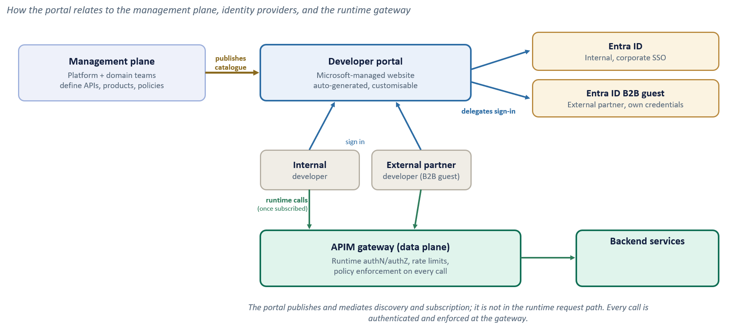
Built-in roles and RBAC
Two separate layers of access apply to the portal: who can see and use it as a consumer, and who can administer or publish its content. Neither creates a local account; both resolve back to Entra ID, consistent with the access model set out above.

Portal groups:
Group | Membership | What it grants
Administrators | Azure subscription administrators | APIM service administration; not a consumer role
Developers | Authenticated portal users | Provides standard portal access, with product visibility determined by group membership
Guests | Anonymous portal visitors | No access under the proposed security model
Custom / Entra ID Groups | Consumer-specific groups such as internal teams or partners | Controls visibility of permitted products
RBAC for administering portal content:
Customising or publishing the portal is a service-administration action, controlled through Azure RBAC rather than the portal groups above.
Role | Scope | Use
API Management Developer Portal Content Editor | APIM Service | Edit, customise and publish Developer Portal content through the Developer Portal administration experience without broader APIM administration
API Management Service Contributor | APIM Service | Full APIM service administration; not intended for portal content editors
Entra ID group membership and products control Consumer access. Portal administration is controlled separately through Azure RBAC.
API Consumer Journey
The below diagram shows the shared journey for consumers with appropriate access for both internal and external consumers.
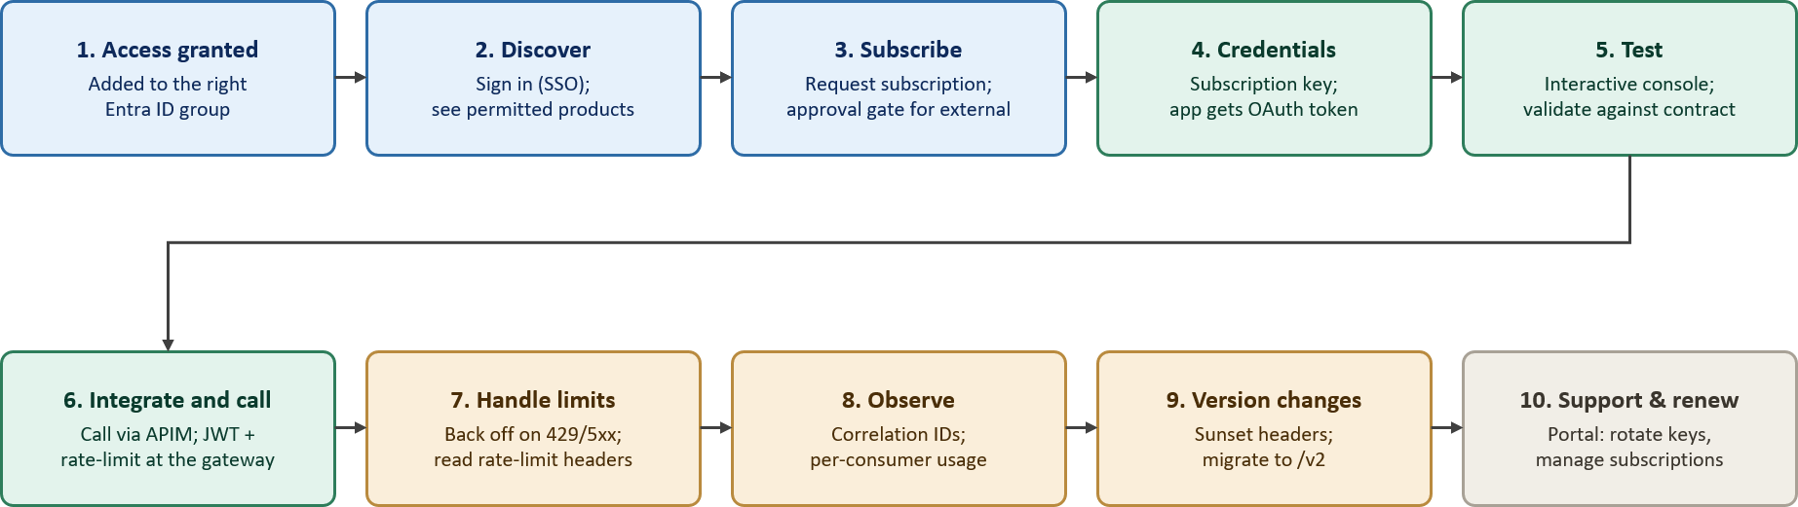
The API consumer journey, ten steps from access granted to steady-state use, support and versioning.

Access Model
Developer Portal access is based only on Microsoft Entra ID. The proposed design does not rely on any local accounts.
- Identity based Visibility. A signed-in developer sees only the products their Entra ID group permits.
- Consumers. Internal users authenticate with corporate SSO and Entra Conditional Access policy will be used to restrict authentication to trusted locations and devices; external partners authenticate as Entra External ID (B2B) guests with their own organisation's credentials. Also, where Developer Portal access is enabled, user session duration, token validity and re-authentication requirements are governed through Entra Conditional Access session controls rather than Microsoft default settings.
- Content administration. Azure RBAC (the Developer Portal Content Editor role) controls customising or publishing content which is separate from consumer visibility. Portal administration is separate from consumer access.

Deployment and Hosting
The current proposal uses the Microsoft-managed APIM Developer Portal. The portal is a management and onboarding capability and is not part of the runtime API transaction path. The selected hosting approach and self-hosted alternative are documented in ADR-10 Developer Portal Hosting, with detailed trade-offs in the architecture decisions appendix.
Developer Portal content is administered through the Microsoft-managed Developer Portal administration experience. Content publication is controlled separately from APIOps deployments and follows the agreed change management and approval process. APIs, products, policies and infrastructure remain managed through APIOps and Infrastructure as Code
Environment Mapping
Each APIM environment has an associated Developer Portal, maintaining separation across Dev, SIT, UAT and Production. Dev and SIT use the Developer tier, while UAT and Production use Premium v2.

Content and Promotion
Developer Portal content promotion between APIM Premium v2 environments is currently not supported, and Microsoft does not recommend or certify an automated Dev → UAT → Prod promotion mechanism for Developer Portal content.
- Portal Content Management – Developer Portal content, including pages, media, styling, layouts and settings, is managed independently within each APIM environment. Unlike APIs, products and policies, Developer Portal content is not currently promoted between APIM Premium v2 environments through a Microsoft-supported automated deployment process. Portal content changes are created, reviewed and published directly within the target APIM environment.
- Environment-Specific Configuration – Each environment (Development, SIT, UAT and Production) maintains its own Developer Portal content, branding, documentation, layouts and settings. Changes made in one environment must be separately applied and published in other environments where required.
- Configuration Management – Environment-specific settings such as identity providers, custom domains, networking configuration, portal access controls and publication state are managed independently for each APIM environment.
- Backup and Recovery – Developer Portal content is not included within APIM backup and restore operations. Recovery procedures therefore rely on maintaining approved documentation, configuration records and environment-specific content management practices.
- APIOps Separation – Standard APIOps processes continue to manage APIs, products, subscriptions and policies through CI/CD pipelines. Developer Portal content is outside the scope of APIOps deployments and is managed separately in accordance with current APIM Premium v2 platform limitations.
- Publication Process – After any Developer Portal content changes are made, the Managed Developer Portal must be published (must be governed through documented change-control and approval processes to ensure traceability and auditability) within the respective APIM environment for the changes to become visible to portal users.
- Connectivity – Connectivity to Microsoft-hosted services required for Developer Portal administration, publishing and runtime operation must be permitted through Chaucer's approved network egress controls.
APIs, products and policies continue to be deployed through the established APIOps CI/CD process. Once APIs and products are deployed to a target APIM environment, they become available within that environment's Developer Portal catalogue. Developer Portal content, documentation, branding and page customizations are managed and published separately within each APIM environment and are not automatically promoted between Premium v2 environments.

Internal Onboarding
Internal consumer onboarding follows the organisation's existing joiner-mover-leaver process and creates no APIM account:
- Request. The consumer's manager or team identifies the product needed.
- Group membership. The user is added to the relevant Entra ID group through the existing identity process.
- Sign-in. The user signs into the developer portal with corporate SSO and is automatically a Developer.
- Discover and subscribe. They see only the products their group permits; internal products are typically auto approved.
- Credentials. A subscription key is issued, and OAuth-protected calls use a token obtained from Entra ID.
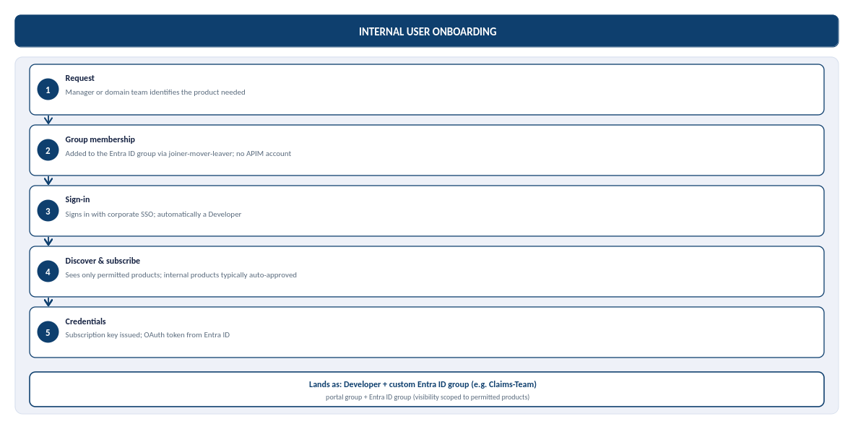

Partner Onboarding
B2B partner onboarding capability is not currently implemented within the target architecture. Any future use of Microsoft Entra ID B2B will require an agreed solution design, security and governance approvals, defined onboarding guardrails, access duration and review requirements, and a documented offboarding/deprovisioning process before partner access is enabled.

Partner (B2B) onboarding is sponsored and gated by approval rather than automatic:
- Sponsorship. A named internal owner sponsors the partner and confirms which product they may access.
- Guest invitation. The partner user is invited as an Entra ID B2B guest, authenticating with their own organisation's credentials.
- Group membership. Once the invitation is redeemed, the guest is added to a per-partner Entra ID group, scoping visibility to that partner's product only.
- Sign-in and subscribe. The partner signs in through B2B guest SSO and requests a subscription; external subscriptions are gated by approval.
- Credentials. On approval, a subscription key is issued, and, for OAuth-protected APIs, the partner's registered application obtains a token from Entra ID.
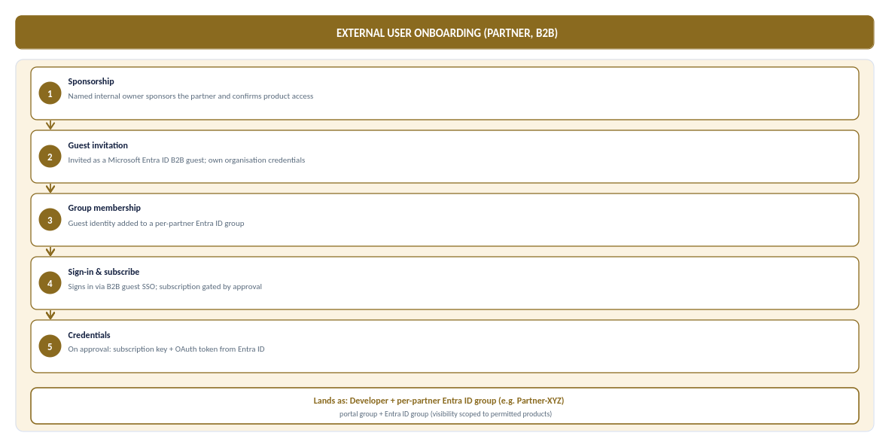

Security Controls
The Developer Portal shall operate under a controlled access model with the following security controls:
- Anonymous access shall be disabled for API documentation and product access.
- Self-service user registration shall be disabled.
- Internal users shall authenticate through Microsoft Entra ID.
- External partners shall authenticate through Microsoft Entra ID B2B guest accounts.
- Product visibility shall be restricted through Entra ID group membership.
- External product subscription requests shall require administrator approval.
- Subscription keys shall be used for consumption tracking and throttling purposes only and shall not be considered an authentication mechanism.
- OAuth 2.0 tokens issued by Microsoft Entra ID shall be the preferred authentication mechanism for all APIs.

API Design, Policies and Lifecycle

Governance Model
API platform governance requires clear separation of ownership while maintaining centralised visibility and control. Workspaces provide logical isolation between teams, while products, subscriptions and Microsoft Entra ID groups control API exposure, access and administration. This approach enables decentralised API ownership within a centrally governed platform.
Choosing each layer: a clear strategy for Products, Consumers and the Portal
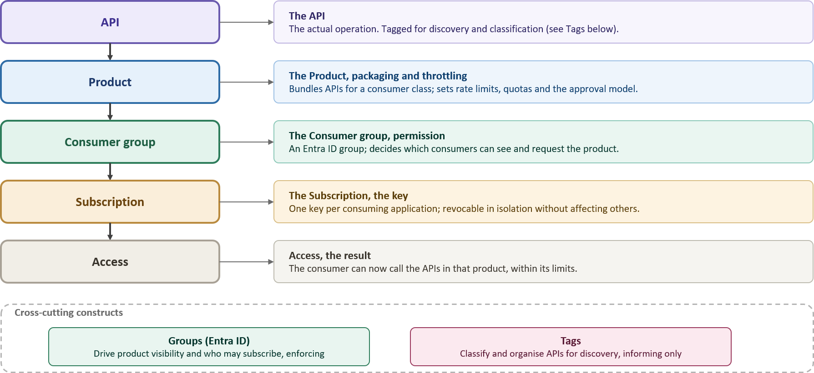
The access model, the core chain plus what each construct controls, including Groups and Tags

Governance Construct | Core Purpose & Architectural Behaviour | Key Governance Rule & Enforcement
Backends | Abstracts downstream target URLs and centralizes runtime resilience rules (circuit breaking, load balancing, retries). | Target URLs and health check policies are managed centrally outside individual API definitions.
Named Values | Provides APIM's key-value store for plain settings (URLs, limits) and Key Vault-backed secret references. | Zero secrets hard coded in policies. All secrets use Key Vault integration and are version-controlled via APIOps.
Policies | Enforces execution logic, transformations, authentication, and rate limits at global, product, or API scopes. | Policies reference Named Values for config; product-level policies enforce class-wide rules once.
Products | Group APIs into consumable offerings with common access and subscription controls. | Consumers subscribe to products rather than individual APIs.
Groups | Controls visibility and subscription access to Products based on user membership. | Custom groups map strictly to Microsoft Entra ID. No local user accounts are created inside APIM.
Tags | Provide categorisation, discovery and reporting metadata. | Tags support discovery and governance only and do not influence runtime behaviour.

How the Governance Constructs Fit Together
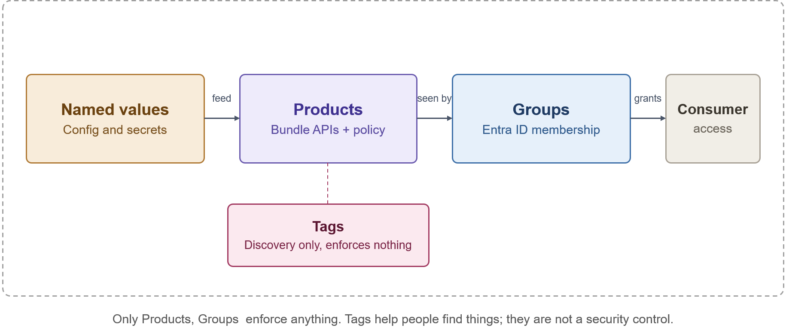

Policy Hierarchy
APIM policies are applied in a hierarchy, with each level inheriting from the one above and able to extend it. This allows platform-wide controls to be enforced centrally while individual APIs add their own behaviour:
- Global (all APIs). Baseline controls applied to every call correlation ID propagation, base security headers and platform-wide defaults.
- Product. Controls applied to all APIs in a product, typically the subscription quotas and rate limits for a consumer class.
- API. Controls specific to an API, including token validation, backend routing and transformations.
- Operation. Controls specific to a single operation, where finer-grained behaviour is required.
Policies are maintained as code and deployed through the pipeline; they are not edited directly in the portal except through approved emergency procedures.

APIM Policy Standards
Standard policy controls are applied across the Azure API Management service to provide consistent enforcement of authentication, validation, rate limiting, logging, and operational governance requirements. Detailed policy definitions and implementation guidance are maintained in the APIM Policy Capability Matrix. [Ref 4]

Lifecycle and Versioning
API versions are managed in accordance with Chaucer Engineering Standards. Breaking changes require a new API version, while non-breaking changes are managed through the standard release process. Deprecated APIs remain available for an agreed transition period before retirement.
Every API follows a standard lifecycle from design through retirement, ensuring consistent governance, security and operational management. The lifecycle aligns with Chaucer's engineering standards and API governance practices, with operational insights and monitoring data feeding future enhancements and design decisions.
Approved API definitions, products, policies and configuration are promoted through Dev → SIT → UAT → Production using the APIOps process defined in Section 11.
Further guidance on API lifecycle management is available in the Chaucer Engineering Standards and API Governance documentation on Confluence: [Ref 5]

Environments and APIOps

Environment Model
Environment | Service tier | Target SLA | Purpose
Dev | Developer | None (No SLA) | Functional API policy development, mock backend testing, and automated pipeline builds at minimum cost. Non-production evaluation tier.
SIT | Developer | None (No SLA) | Functional API policy development, mock backend testing, and automated pipeline builds at minimum cost. Non-production evaluation tier.
UAT | Premium V2 | 99.95% | Pre-production business sign-off and user acceptance. Guarantees complete architectural parity with Production (VNet Injection, Private Endpoints, isolated networking) on a single scale unit.
Production | Premium V2 | 99.99% | Live customer traffic, high availability. Deployed across 2 Availability Zones (Silver Tier) with dynamic autoscaling based on gateway CPU/Memory load

The platform environment strategy uses four distinct environments: Dev, SIT, UAT, and Production.
- Dev and SIT: Provisioned on the cost-effective Developer tier to support functional API policy development, mock testing, and automated integration pipeline builds at minimal cost.
- UAT: Provisioned on Premium v2 (1 scale unit) to ensure complete pre-production architectural and network parity (VNet Injection, Private Endpoints) with Production, providing a supported, SLA-backed platform for business sign-off and user acceptance testing.
- Production: Provisioned on Premium v2 with Zone Redundancy enabled (Silver Tier across 2 Availability Zones) for live customer traffic, maximum platform availability, and dynamic autoscaling capabilities.
Each APIM environment has an associated Developer Portal. Portal hosting, environment mapping and content-promotion arrangements are defined in Section 9.3 and Section 9. 4.

APIOps
This design adopts an APIOps operating model, aligned to Chaucer's existing Azure delivery approach and platform engineering standards.
- Infrastructure as code: Terraform is used to provision and manage APIM, networking, Front Door, Key Vault and supporting Azure resources. Environment-specific behaviour is controlled through approved configuration and parameterisation rather than separate infrastructure definitions.
- Configuration as Code: APIM APIs, products, policies, named values and related configuration are maintained in source control and deployed through automated pipelines. Configuration is managed as code rather than through manual changes in the Azure portal.
- Source Control and CI/CD: Azure Repos provides source control, with Azure DevOps Pipelines used for build, validation and deployment. All changes are subject to pull-request review and approval prior to deployment.
- Environment promotion: Changes are deployed to Development through the CI/CD pipeline and promoted through SIT, UAT and Production using the same approved artefacts. Production deployments are governed through approval gates and change management processes
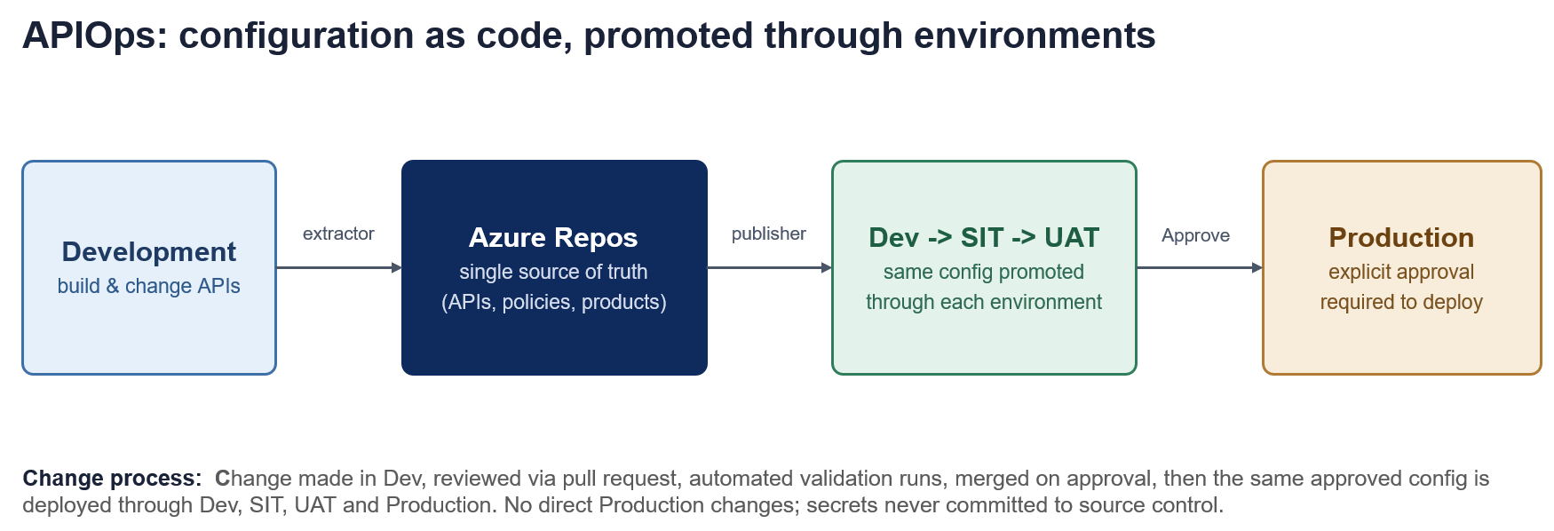
Configuration Management
Environment-specific settings such as backend endpoints, rate-limit thresholds and timeout values are managed through environment-specific configuration files. API definitions, OpenAPI specifications and policies remain consistent across all environments.
Security Baseline
- Secrets Governance – Credentials, certificates and keys are stored in Azure Key Vault and referenced securely during deployment and runtime. No plain-text secrets are committed to source control.
- Least Privilege – Deployment identities use scoped credentials and the minimum required Azure RBAC permissions.
- Pipeline Enforcement – Production changes are deployed exclusively through approved CI/CD pipelines.
- Emergency Override – Direct production access is restricted to approved, time-bound emergency access procedures using Azure PIM.

Component Configuration
This section defines the target configuration for the core platform components, including Azure API Management (APIM), Azure Front Door (AFD), and the Developer Portal. The configuration values provide the baseline deployment specification required to support the target architecture, security model, networking approach, operational requirements, and non-functional requirements defined within this HLD.
The detailed configuration parameters for each component are provided in the accompanying Parameter Sheet. These values are indicative and intended to support design and planning activities. Prior to implementation, all parameters must be reviewed, validated, and confirmed by the Cloud Engineering team as part of detailed design and deployment planning to ensure alignment with Chaucer engineering standards, environment-specific requirements, and operational constraints. [Ref 1]

Reliability and Backup Strategy

Resilience
High Availability ensures the platform survives a datacentre failure within a region without disrupting users. By deploying APIM across independent Azure Availability Zones, traffic is automatically routed only to healthy zones.
Active-active multi-region deployment doubles overall platform running costs, which is not justified for every API. To balance high availability with fiscal responsibility, resilience is tiered based on business criticality rather than paying a multi-region cost premium across the entire estate and hence the chosen baseline is the Silver resilience tier where a single region is selected and multiple units deployed across Availability Zones.

Deployment-Unit Implication
Platform capacity and resilience scale with the number of provisioned units. The chosen Silver production baseline uses at least two units distributed across Availability Zones, so the loss of a single zone does not take the platform offline, and traffic is automatically served by the remaining healthy zones.
In case of upgrade to Gold tier, each active region must carry at least one unit to absorb the full peak workload during a single-region failover.
In both cases the actual number of units used also depends on the workload.

Backup, Restore and Rebuild
The platform is delivered as code, making rebuild-from-code the primary recovery mechanism for platform configuration and infrastructure. The APIM configuration, policies, products and infrastructure definitions are held in source control, so an environment can be reprovisioned to a known-good state from the repository.
- Configuration recovery. APIM APIs, products, policies and named values are restored by redeploying the versioned configuration through the pipeline.
- Infrastructure recovery. The Terraform definitions reprovision the APIM instance, networking and supporting resources.
- Secrets and certificates. These remain in Azure Key Vault and are referenced at runtime, so they are not re-created as part of a configuration rebuild.

RTO and RPO
Recovery objectives differ by resilience tier. Because platform configuration is held as code, the configuration recovery-point objective is effectively near-zero, the last committed state can always be redeployed.
- Silver (production baseline). Zone failure is managed automatically within the region with no meaningful interruption. Microsoft provides an availability of 99.99% for this baseline. A total regional outage is recovered by deploying to the secondary region from code, accepting an extended recovery-time objective in exchange for not running a permanent standby region.

Observability and Operational Management

Monitoring Architecture
Azure Monitor provides a unified observability platform across APIM, policies and backend services. Application Insights delivers end-to-end tracing, Log Analytics stores diagnostic telemetry, and dashboards provide operational, security and management reporting.
As illustrated in the architecture below, telemetry is ingested from four primary sources:
- APIM Gateway Metrics capture platform performance and resource utilization.
- Application Insights records distributed request flows and application telemetry.
- Azure Front Door / WAF supplies edge security and traffic inspection logs.
- Diagnostics provide underlying component health data.
All incoming streams converge into Azure Monitor / Log Analytics as the central data store, which in turn powers role-specific Dashboards and Workbooks for integrated operational insight.
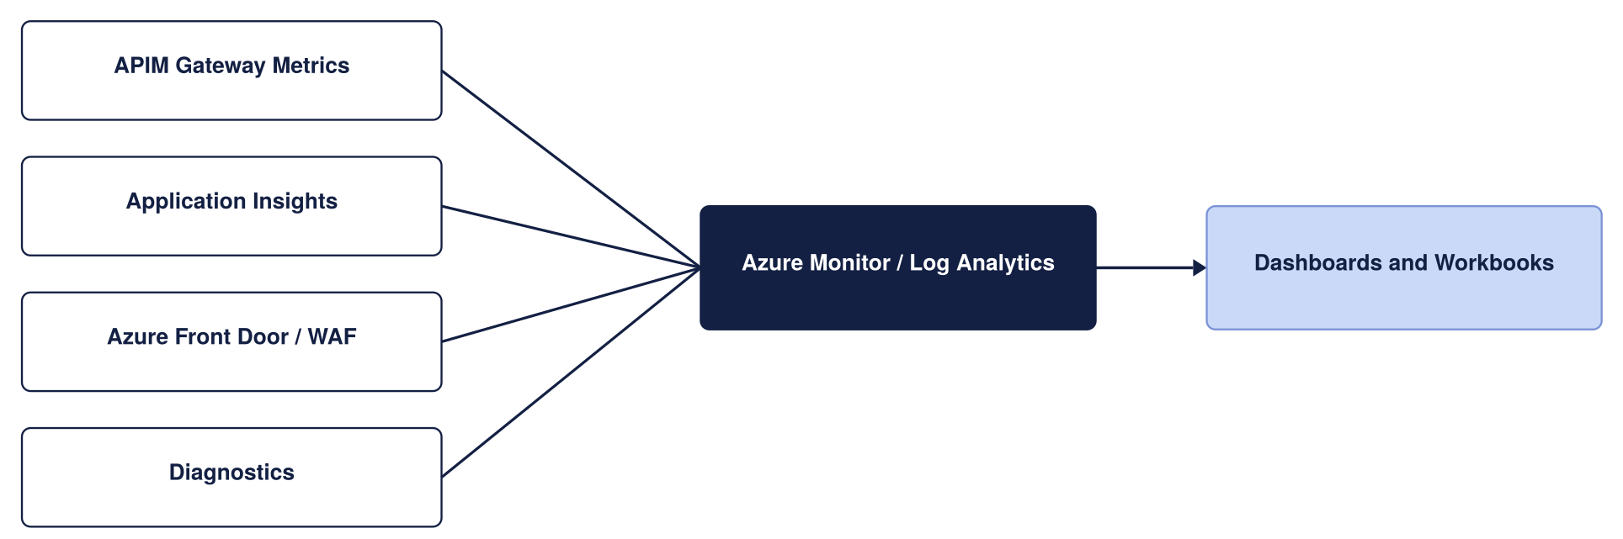
Monitoring architecture

Telemetry
Telemetry is captured through APIM diagnostic settings and routed to the appropriate platform based on its purpose, retention requirement, and security classification:
- Operational and performance: Gateway request and response metadata, latencies, and throughput, used for health and capacity monitoring.
- Diagnostic: Detailed diagnostic logs in Log Analytics; verbose policy tracing is restricted to non-production environments to control cost and protect sensitive data.
- Security: WAF and security-relevant logs, which are also forwarded to the central security monitoring platform (SIEM).
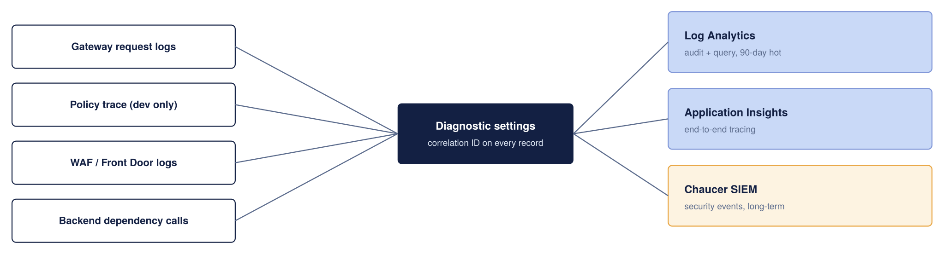
Telemetry Collection and Retention

Detailed telemetry destination mappings, retention requirements, security classifications, and operational ownership are maintained in the Telemetry Routing and Retention Matrix. [Ref 4]
Correlation and Tracing
Correlation identifiers are propagated from APIM to backend services to support end-to-end request tracing. Trace propagation should be validated during implementation to ensure continuity across distributed systems. Verbose policy tracing is restricted to non-production environments to protect sensitive data and control telemetry costs.

Dashboards and Alerts
Operational dashboards and alerts provide visibility of service health, performance, availability, and security events across Azure API Management, Azure Front Door, and supporting platform services.
Detailed dashboard definitions, monitored metrics, alert thresholds, notification channels, escalation routes, and support responsibilities are maintained in the Dashboard and Alerting Standards. [Ref 4]
Threshold values are indicative starting points and should be tuned based on production traffic patterns and operational experience.

Capacity and Cost

Capacity
The costs below are indicative UK South list prices and should be validated against current Microsoft pricing, enterprise agreements.
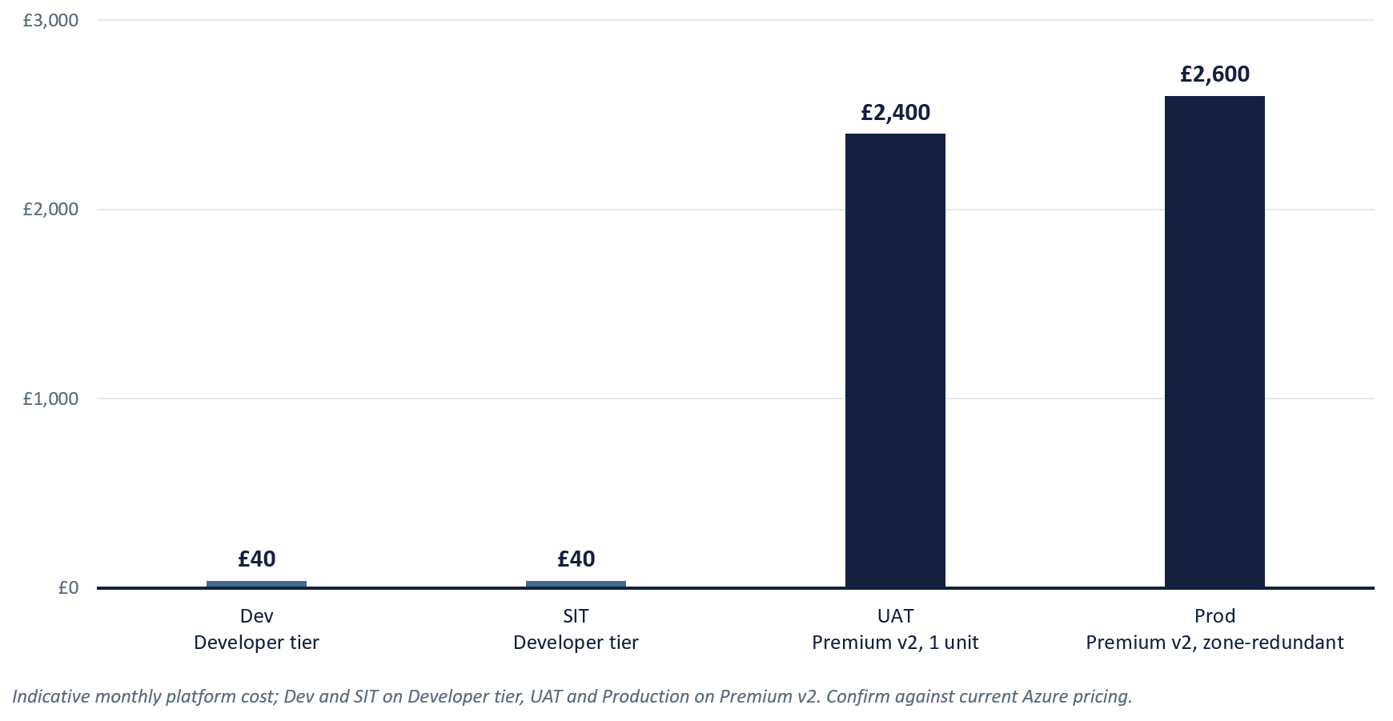
Cost per Component (Production)
Component | Indicative monthly cost | Notes
APIM Premium V2 | ~ £2,100 to £2,300 (per unit) | Modern v2 architecture eliminates legacy Cloud Services (Classic) dependencies. Zone redundancy (2 AZs) is configured within the region.
Azure Front Door Premium + WAF | ~ £260 base, plus usage | In Premium v2, multi-region failover relies on Front Door orchestrating independent regional v2 instances. Includes WAF base rules
Azure Key Vault | Low cost | Centralized secret and TLS certificate storage; operational cost is negligible.
Azure Monitor and Application Insights | Usage-Based | Cost driven by telemetry volume and retention requirements.
Azure DDoS Protection (Dedicated Plan) | ~ £2,300 per month per tenant | Flat tenant-wide fee covering up to 100 public IPs (optional if relying purely on Front Door edge protection).

Capacity Planning and Scaling
Platform capacity scales with the number of provisioned APIM units. Actual throughput depends on factors such as payload size, policy complexity, backend latency and TLS overhead, and should be validated against production traffic characteristics.
Scaling Principles:
- Auto scale Thresholds: For multi-unit instances, scale out when sustained gateway CPU or memory exceeds ~70%, and scale in below ~35% over a 30-minute average.
- Provisioning Lead Time: Scale operations take 15–30 minutes to complete. Auto scale rules must react to sustained trends rather than short bursts.

Environment | Service Tier | Starting Capacity | Indicative Throughput | Architectural & Sizing Justification
Dev | Developer | 1 Unit | N/A | Supports API development, policy authoring, functional testing and APIOps validation with capabilities aligned to the target production model at minimal cost.
SIT | Developer | 1 Unit | N/A | Supports integration testing, environment validation and pre-UAT verification without Premium-tier licensing costs.
UAT | Premium v2 | 1 Unit | ~1,000 requests/sec | Production-aligned environment supporting VNet Injection, private connectivity and enterprise networking validation prior to business sign-off.
Production | Premium v2 | 2 Unit | ~1,000 requests/sec  per unit | Recommended Silver-tier production baseline. Deployed across Availability Zones for high availability and scaled based on observed demand, operational metrics and service-level objectives.

Cost Drivers
The key factors which primarily determine platform cost:
- APIM Units: The number of provisioned Premium v2 units, which directly affects both platform capacity and cost.
- Edge: Azure Front Door Premium and WAF provide the secure public ingress layer.
- Observability: Application Insights and Log Analytics, which are usage-based and scale with telemetry volume and retention.
- Non-Production Environments: Developer tier is used for Dev and SIT, while UAT uses Premium v2 to provide production-aligned validation without additional resilience costs.

Cost Controls
Platform costs are kept proportionate to business need through four core controls:
- Right-Sized Environments: Developer tier is used for Dev and SIT, while UAT uses a single Premium v2 unit to provide production-aligned validation without the cost of additional resilience tiers.
- Just-In-Time Scaling: Production starts with the approved Silver-tier baseline and scales based on observed demand, capacity metrics and service-level requirements.
- Disciplined Telemetry: Log volume is controlled via intelligent request sampling, selective verbose diagnostics for high-value APIs, and strict data retention limits.
- Tiered Resilience: High availability is achieved through a two-Availability-Zone deployment within a single region, avoiding unnecessary multi-region costs where they are not justified by business requirements.

Operating Model

Ownership
APIM introduces a shared API platform with responsibilities aligned to existing Chaucer teams and operating practices. Ownership is distributed across established organisational functions, with existing governance, operational and support processes continuing to apply.
Component | Primary Owner | Supporting Teams
APIM Service  (Gateway, APIs, Products, Subscriptions, Backends) | Integration Team | Application Teams
APIM Policies  (Global, Product, API, Operation, Policy Fragments, Rate Limits, Quotas) | Integration Team,  DevSecOps (Build), | DevSecOps (Security)
APIM Security Configuration  (OAuth/JWT Validation, Managed Identities, Named Values) | Integration Team,  DevSecOps (Security) | M365 Team
Developer Portal  (Content, Branding, Configuration, Publication) | Integration Team | Application Teams, M365 Team
APIOps Configuration Repository and Deployment | Integration Team | DevSecOps (Build)
Azure Front Door  (Profile, Origins, Origin Groups, TLS Configuration) | DevSecOps (Platform),  DevSecOps (Build) | Integration Team
WAF Policies, Rules and Exceptions | DevSecOps (Security) | DevSecOps (Build)
Networking  (VNETs, Subnets, NSGs, Routing, Private Link, DNS Integration) | DevSecOps (Platform) | DevSecOps (Build),  DevSecOps (Security)
Identity and Access Management  (Microsoft Entra ID, Groups, Conditional Access, Managed Identities) | M365 Team,  DevSecOps (Build) | Integration Team
Secrets and Certificate Management  (Key Vault, Certificates, Secret Lifecycle) | DevSecOps (Build) | DevSecOps (Security), Integration Team
CI/CD Platforms and Deployment Automation  (Azure DevOps, Terraform Pipelines, APIOps Tooling) | DevSecOps (Build) | Integration Team, DevSecOps (Platform)
Monitoring and Observability  (Azure Monitor, Log Analytics, Application Insights, Dashboards, Alerts) | Integration Team | DevSecOps (Platform)
Security Monitoring and Compliance  (SIEM Integration, Security Monitoring, Exception Management) | DevSecOps (Security),  DevSecOps (Build) | Integration Team
Platform Resilience, Recovery and Capacity Management | Integration Team,  DevSecOps (Build) | DevSecOps (Platform)
Backend Applications and Business Services | Application Teams | Integration Team

Existing Processes
The operating model reuses existing Chaucer processes rather than creating parallel ones. Identity lifecycle management follows the existing joiner-mover-leaver process, change is governed through established change-management and approval processes, and service transition, incident and problem management follow the organisation's existing service-management framework.
This section is complemented by the Chaucer Engineering Standards and API Governance documentation, which remain the authoritative source for detailed delivery, operational and governance guidance in document Enterprise DevOps Principles. [Ref 6]

Architecture Impact Assessment
The following section gives indication to the impact on architectural domains.

High Level Impact Assessment

Domain | Impact | Strategic Alignment | Complexity
Business
Application
Data
Technical
Security
Service

Business Architecture
Impact - No change to core business capabilities, customer journeys, organisational structure or business processes has been identified.
Strategic alignment - Supports automation, improved system-to-system data flow, reduced point-to-point integration, consistent API usage and business-capability-aligned service reuse.
Complexity - No material Business Architecture complexity is identified. API onboarding, product administration and subscription approval are technology-governance and service-management concerns rather than changes to business processes.

Application Architecture
Impact - Applications exposing or consuming managed APIs or intending to do so may require changes to endpoints, authentication, API contracts, error handling and telemetry.
Strategic alignment – Aligns with the SIF direction to integrate existing systems, promote reusable services and use APIM as the single managed API ingress point.
Complexity - Complexity arises from onboarding existing interfaces, maintaining compatibility, supporting internal and external access paths, introducing OAuth 2.0 and managing API versions via a new platform.

Data Architecture
Impact - APIM does not introduce a new system of record, analytical data store or business-data ownership model. API payloads continue to be owned and processed by the relevant source and target applications.
Strategic alignment – Supports controlled data accessibility between systems while preserving the SIF position that the data platform is not the default mechanism for real-time or transient integration.
Complexity - Each API hosted or accessed via the platform still requires data classification, payload-handling rules, logging restrictions, masking and retention decisions.

Technology Architecture
Impact - Introduces a shared platform comprising APIM, external-edge protection, private networking, identity, secrets management, monitoring and automated delivery. It creates dependencies on the Azure landing zone, DNS, routing, hybrid connectivity and deployment pipelines.
Strategic alignment – Aligns with the stated adoption of Azure PaaS integration services and the principles of managed identity, Key Vault, source control, CI/CD, monitoring and observability.
Complexity – Few design points remain subject to implementation validation, including Premium v2 networking, private-origin connectivity, and Availability Zones

Security Architecture
Impact - The proposed architecture improves the control position by introducing a managed API gateway, OAuth 2.0 and Entra ID authentication, edge protection, private connectivity, managed identity, Key Vault and central policy enforcement. This directly addresses the security requirements for private API access and protection against common web and API attacks while ensuring any public API access is authorised only via the TDA route.
Strategic alignment – Aligns with the SIF security principles and APIM requirements for managed identity, Key Vault, secure access, Entra ID, OAuth 2.0, DDoS protection and OWASP-related controls.
Complexity - Delivery spans edge, identity, gateway, network, backend and monitoring controls. API hosted or accessed via the platform require managing Partner identity, certificate ownership, and logging.

Service Architecture
Impact - APIM becomes a new shared platform requiring defined ownership, monitoring, alerting, capacity management, certificate management, incident support and recovery.
Strategic alignment – High availability, backup, disaster recovery, observability, policy control and segregated release environments align to a standard support model.
Complexity - Operational complexity is distributed across Integration, Platform, Network, Identity, Security and Operations.

RAID

Risks
No active risks have been recorded at this stage. Risks identified during review, implementation or operation should be logged and monitored through the appropriate governance process.

Assumptions
This register identifies assumptions and outstanding decisions requiring validation and approval prior to implementation.
Ref | Assumption or open item | Impact if Incorrect | Owner
A.01 | Backend services are reachable through approved private connectivity. | Backend connectivity design may require rework. | Network team
A.02 | Entra ID is the Organization’s identity provider and can extend to API consumers | Authentication and authorization model may require redesign. | M365 Team
A.03 | Proposed RTO/RPO, retention periods, and alert thresholds are acceptable | Operational targets and cost may change | Integration Team
A.04 | Initial workloads can be supported by a two Premium v2 unit. | Additional capacity may be required earlier than planned. | Integration Team
A.05 | Expected and peak API request rate (RPS) are not yet confirmed | Capacity planning remains indicative until validated. | Platform team
A.06 | Operational ownership and RACI assignments are not yet confirmed. | Governance and support responsibilities remain incomplete. | Platform Team and Service Owners
A.07 | Log retention and correlation-data retention requirements are not yet confirmed. | Compliance and audit requirements may not be fully satisfied. | Security Teams
A.08 | Network sizing and IP allocation requirements are not yet validated. | Subnet sizing and platform scalability assumptions may be affected. | Network Team
A.09 | Parameter values defined for APIM, Azure Front Door, and Developer Portal are indicative and will be validated during implementation. | Incorrect sizing, networking, security, or deployment configuration may require redesign, rework, or environment changes during delivery. | Cloud Engineering Team
A.10 | Developer Portal content promotion between APIM Premium v2 environments is not currently supported by Microsoft. Therefore, portal content changes will be manually replicated, validated and published in each environment until Microsoft releases a supported content migration or deployment capability. | This approach introduces additional operational overhead, increases release and validation effort, and presents a risk of content inconsistencies between environments. Appropriate change-control, documentation, and governance processes will be required to ensure traceability, auditability, and alignment of Developer Portal content across environments. | Integration Team

Issues
No active issues have been identified at this stage. Issues identified during review, implementation or operation should be logged and tracked through the appropriate governance process.

Dependencies
Ref | Dependency | Owner
D.01 | Entra ID app registrations provisioned before build | M365 Team

Appendices

Microsoft WAF Alignment
This design has been benchmarked against Microsoft's Azure Well-Architected Framework guidance for Azure API Management. The table below summarises how the proposed architecture aligns with the five Well-Architected Framework pillars.
WAF Pillar | Key Microsoft Recommendations | How This APIM Design Addresses It
Reliability | Zone redundancy, autoscaling, regional resilience, policy validation, reliability metrics and configuration recovery. | APIM Premium v2 is deployed across multiple Availability Zones within a single region (Silver Resilience Tier). Zone redundancy provides protection against zonal failures, while APIOps configuration-as-code supports rapid environment recovery and rebuild.
Security | Strong identity controls, TLS enforcement, Key Vault integration, network isolation, OAuth 2.0, Managed Identity, edge protection and restricted diagnostics. | Microsoft Entra ID OAuth 2.0 with JWT validation, TLS 1.2+ minimum, Key Vault-backed Named Values, Azure Front Door WAF protection, Managed Identity for backend access, Private Endpoints and restricted verbose tracing outside non-production environments.
Cost Optimisation | Appropriate service-tier selection, autoscaling, edge filtering, efficient policy execution and controlled observability costs. | Four-environment model with Developer tier for Dev and SIT, and Premium v2 for UAT and Production. Azure Front Door WAF and edge filtering reduce unnecessary traffic reaching the gateway, while telemetry and scaling are managed according to demand.
Operational Excellence | Centralised monitoring, APIOps workflows, automation, governance controls and standardised deployment processes. | Azure Monitor, Log Analytics and Application Insights provide platform observability. APIOps CI/CD pipelines, infrastructure as code, standardised onboarding processes and automated deployments support operational consistency and governance.
Performance Efficiency | Dynamic scaling, efficient policy execution, performance monitoring, telemetry optimisation and capacity planning. | Capacity scales through APIM Premium v2 units, supported by performance monitoring, capacity alerting, policy optimisation and production telemetry sampling to minimise overhead while maintaining visibility.

Architecture Decisions Explained

19.2.1. Edge Service Components (ADR-01)
The table below shows how each edge gateway option aligns with the defined requirements, providing the basis for selecting the preferred edge gateway service.
Option | Architectural Intent | Requirements Alignment | Operational Complexity | Indicative Monthly Cost* | Recommended
Front Door Premium + WAF (Selected) | Global Edge, Multi-Region & Unified Ingress | Meets R1, R4, R5, R6, R7, R8, R11, R12 | Low | ~£255 | Yes
Application Gateway v2 + WAF | Regional-Only Ingress & Data Residency | Partial alignment. Meets R5 and R6 but limited support for R1, R7, R8 and R11. | Medium | ~£253 | No
Front Door Premium + Application Gateway v2 + WAF | N-Tier Ingress & Defence-in-Depth | Meets all requirements but introduces additional infrastructure and operational overhead. Duplicating WAF, routing and certificate management increases complexity, slows troubleshooting and deployments, and requires additional Application Gateway instances in every region, driving linear growth in cost and management effort. | High | ~£515 | No
Direct APIM Ingress  (No Edge Service) | Internal-Only APIs | Suitable only for internal consumption scenarios. Does not meet R1, R6, R7, R8 or R11. | Low | £0 | No
Traffic Manager | DNS-Based Global Routing & Failover | Fails core protection and access requirements. Only routes at the DNS layer, completely failing R2 (secure access), R4/R5 (endpoint isolation), and R6 (WAF/DDoS protection). Satisfies R7/R8 (HA/DR) and R11 but cannot function as an API ingress. | Low | ~£5 to £15 | No

Front Door Premium + WAF (Selected)
Architectural Intent: Global Edge, Multi-Region & Unified Ingress
Front Door Premium + WAF is the requirements-aligned, cost-effective choice: it meets every requirement in this matrix. It combines global routing, managed WAF/DDoS, and native Private Link into APIM within a single, low-maintenance service, satisfying R1 (discovery and consumption by internal and external users), R4 (controlled private and public endpoint access), R6 (DDoS and OWASP Top 10 protection), R7 (high availability), R11 (Traffic Manager-equivalent global routing) and R12 (low operational complexity for cost-effective, segregated environments).

19.2.2. APIM Premium v2 (ADR-02)
This section evaluates APIM Premium v2 against the available APIM tiers and identifies Premium v2 as the preferred platform standard. Premium v2 best aligns with the target architecture requirements for security, scalability, networking, and resilience, while the Developer and Standard v2 tiers provide insufficient secure capability needed for Production and UAT environments.
Capability | Premium v2 | Classic Premium | Decision & Rationale
Simplified Networking Model | Yes | No | Premium v2 significantly reduces virtual network governance overhead by eliminating dedicated control-plane routing dependencies.
Private Networking / Isolation | Yes | Yes | Both tiers fulfil strict security policies by providing private endpoint connectivity and network isolation
Workspaces | Yes | Yes | Both tiers support workspaces for decentralized API publishing and domain isolation across business units.
Futureproofing | Yes | No | Premium v2 positions the platform on Microsoft's newest architecture, avoiding future migration rework from Classic Premium.
Multi-Region Topology Strategy | Regional Deployment | Native multi-Region | Premium v2 supports single-region zone redundancy per instance, aligning perfectly with our Silver Resilience Tier
Backup and Restore | No | Yes | Premium v2 does not provide the native APIM backup/restore capability available in Classic Premium. Platform recovery therefore relies on redeployment of infrastructure and configuration from source controlled Terraform and APIOps artefacts.

19.2.3. APIM Network Model (ADR-03)
To ensure a strict security boundary, Azure API Management requires isolation from direct internet exposure. Selecting the deployment mode dictates how the gateway integrates with our virtual network (VNet) and forces all external consumer traffic through Azure Front Door Premium WAF via Private Link.
The table below details the evaluation between Internal VNet, External VNet modes and VNet Integration.
Option | Description | Status | Architectural Rationale
VNET Injection Internal mode | APIM is deployed inside a VNet subnet with no public IP address. Ingress from Front Door Premium is via Private Link / Private Endpoints, and backend access uses private VNet routing. | Chosen | Zero Internet Exposure: Completely isolates the API gateway from the public internet. Guarantees that all external traffic is inspected and forced through Azure Front Door Premium WAF before reaching APIM.
VNET Injection External mode | APIM sits inside a VNet but maintains a direct, publicly accessible IP address on the internet, allowing clients to bypass or hit the gateway alongside an optional edge service. | Not Chosen | Security & Compliance Risk: Exposes a public surface area directly to the internet, creating potential governance bypasses where consumers can hit APIM endpoints without traversing the centralized Front Door WAF edge.
VNET Integration | APIM connects to backend services through a dedicated integration subnet, allowing private access to internal networks, Azure services, and external SaaS platforms without exposing a public IP for outbound traffic. | Not Chosen | Backend Reachability: This option still exposes a public surface area to the internet while achieving access to backend services without introducing a dedicated integration subnet and associated networking complexity. By supporting private access to Azure and external services, the selected approach provides sufficient connectivity while maintaining a simpler operational model and lower cost.

19.2.4. Resilience Tiers (ADR-09)
Resilience Tier | Deployment Topology | Architectural Scope | Operational Effect | Key Benefits | Architectural Trade-offs
Bronze | Single Region,  Single Unit | APIOps / IaC Git Config Recovery  Azure Front Door Anycast & WAF Edge | Environment can be rebuilt from code (near-zero config RPO).  DDoS and web attacks absorbed at the edge. | Minimizes platform infrastructure, licensing, and operational management costs. | No cross-zone or cross-region failover. Relies entirely on standard platform recovery procedures during outages.
Silver (Chosen Baseline & Production Standard) | Single Region,  Multiple Units (2 AZs) | Zone-Redundant APIM Gateway | Survives single physical datacentre loss within the region.  Traffic automatically routes around failed zones without manual intervention. | High intra-region availability and fault tolerance against local zonal/maintenance events. | Accepts downtime for entire cloud region outage. Saves on costs and complexity associated with multi-region deployment.
Gold | Multi-Region,  Multiple Units | Multi-Region Active-Active APIM (UK South / UK West)  Front Door Global Health Probes | Full regional disaster recovery.  Total UK South outage automatically routes traffic to UK West or another approved region with no client DNS changes. | Highest resilience tier with automated geographic failover and continuous multi-region availability. | High operational complexity and doubles platform operational costs.

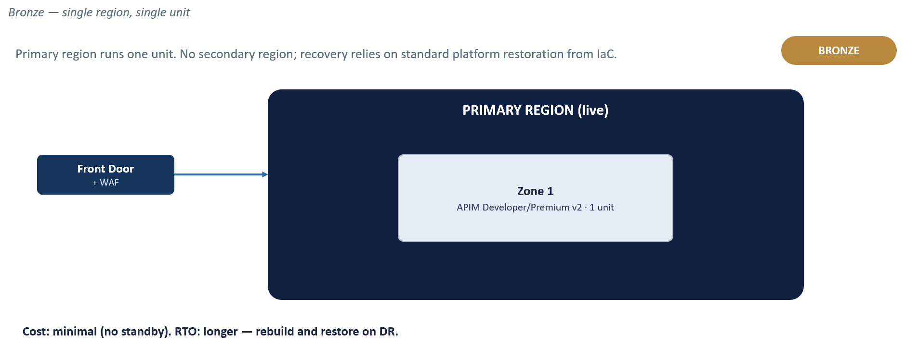

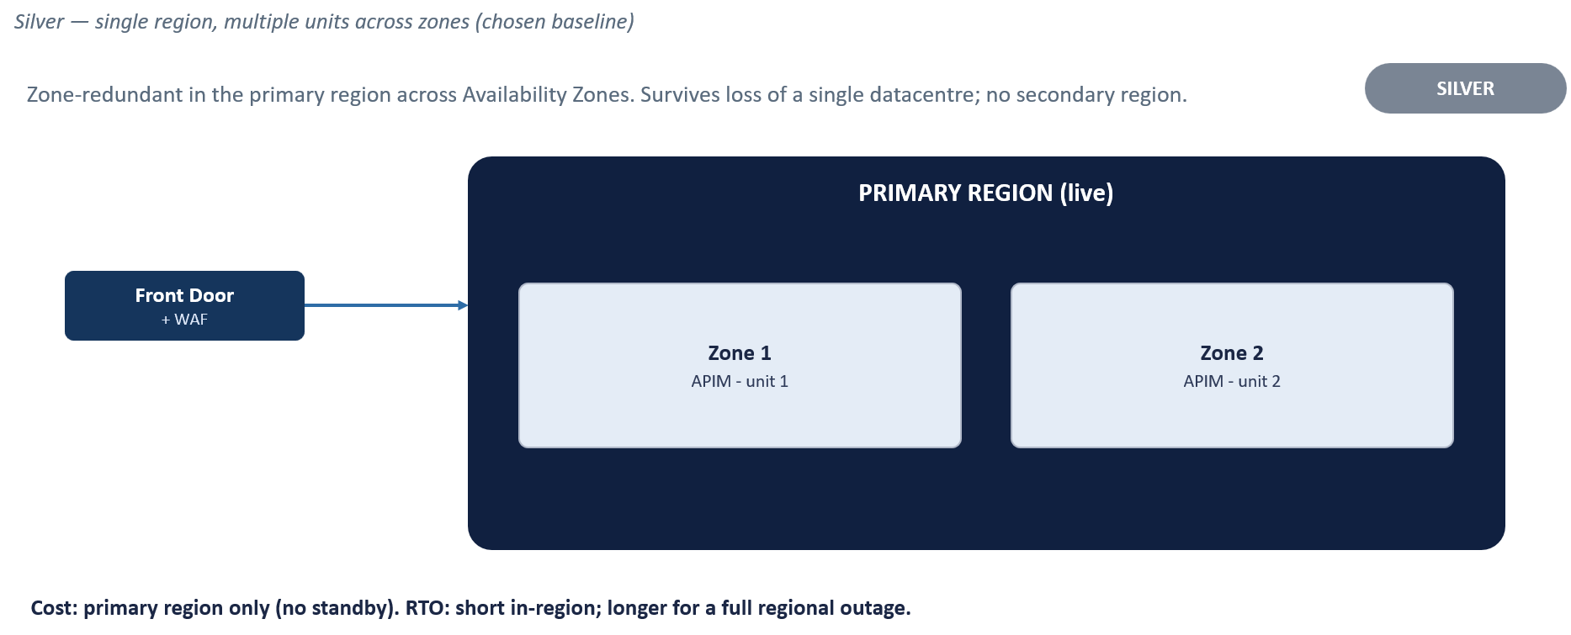

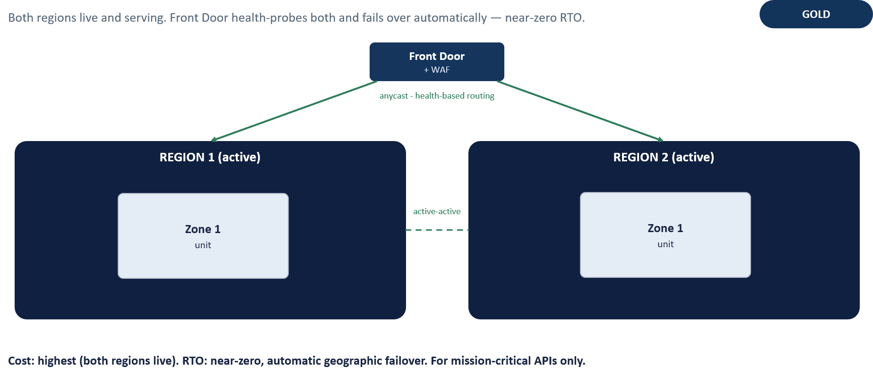

19.2.5. Developer Portal Hosting (ADR-10)
The Developer Portal is needed for API discovery, documentation, testing and subscription management. Two hosting approaches were evaluated against Chaucer's security requirements, external-consumer needs, implementation efforts and ongoing operational overhead. The Managed Developer Portal approach was chosen.

Capability / Consideration | Managed Developer Portal (Chosen) | Self-Hosted Developer Portal
Hosting | Microsoft-managed as part of APIM | Chaucer-managed hosting, such as Azure App Service
Infrastructure | No additional hosting infrastructure required | Additional hosting, networking and supporting resources required
Maintenance | Platform hosting and maintenance managed by Microsoft | Chaucer owns hosting, upgrades, security patching and maintenance
Customisation | Supports branding, pages, styling and content customisation within the managed portal framework | Provides greater control over portal code, functionality and user experience
Internal Access | Supported through Microsoft Entra ID authentication and Conditional Access policies restricting access to approved Chaucer users, devices and locations | Can be designed using Chaucer-controlled private connectivity
External Access | Portal remains internet accessible. Access is restricted through Microsoft Entra ID and Conditional Access policies. External partner access is not included within the initial implementation | Can be published through Chaucer-controlled access paths and security controls
Portal Content Promotion | Portal content promotion between APIM Premium v2 environments is not currently supported through a Microsoft-supported automated migration mechanism. Content changes must be maintained and published separately in each environment | Deployment and content-promotion processes would require separate assessment and implementation. Microsoft does not currently provide a supported portal-content migration capability for APIM Premium v2 environments
Operational Overhead | Low | High
Cost | Included within the APIM service, excluding supporting identity and security services | Additional hosting, monitoring, networking and delivery costs
Future Migration | Current proposed approach | Retained as an alternative if future requirements justify additional complexity and control
Self-Hosted Portal Design Considerations
If self-hosting is required, the following additional capabilities must be introduced:
- Hosting and Networking – Deploy the portal on a Chaucer-managed hosting platform, such as Azure App Service, with the required network connectivity, DNS configuration and security controls.

- Infrastructure – Extend the infrastructure deployment to include the portal hosting platform, supporting network configuration, DNS services and any required ingress components.
- Portal Lifecycle Management – Establish processes for portal deployment, configuration management, upgrades, maintenance and change control. Portal content management and promotion capabilities must be assessed against Microsoft-supported functionality available at the time of implementation.
- APIM Connectivity – Provide controlled connectivity from the portal hosting platform to the required APIM developer portal backend services and management interfaces, including authentication, authorisation and DNS resolution requirements.

- Monitoring – Integrate hosting, application, access and security telemetry with the platform observability and security-monitoring model.

- Access Controls – Design and implement the required authentication, authorisation and consumer visibility controls for the self-hosted solution.

Recommendation: The Managed Developer Portal remains the preferred approach for the current deployment due to its lower infrastructure, operational and support overhead. Self-hosting remains a future option if private-only access, network isolation or advanced customisation become mandatory requirements.
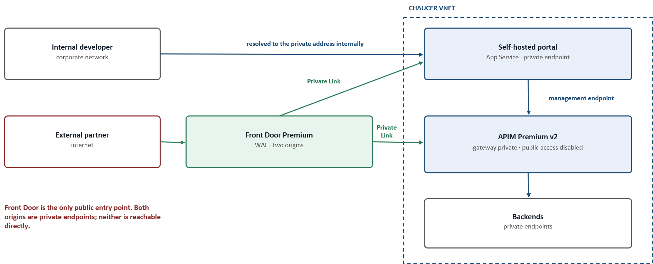

Platform Implementation Stages
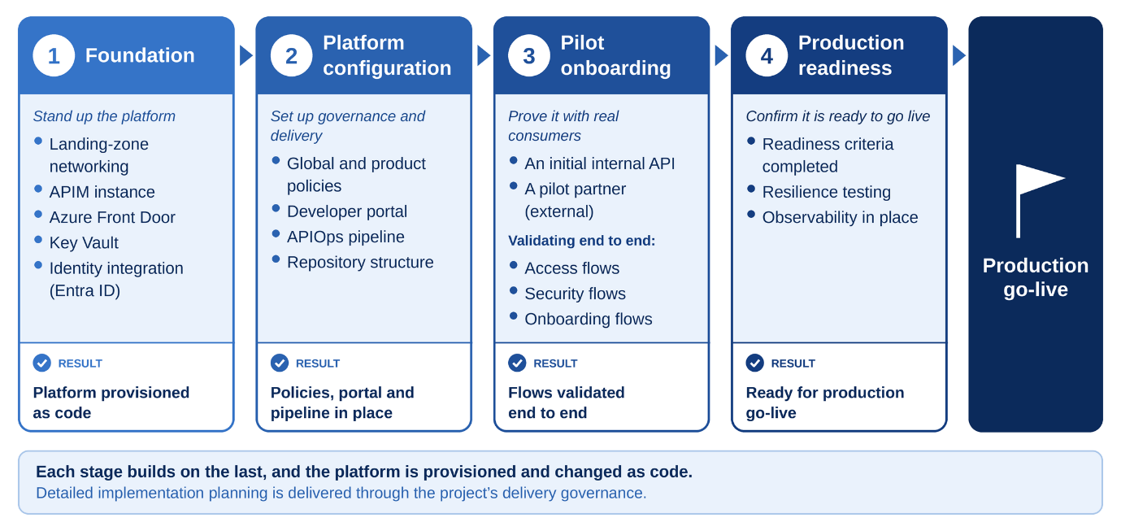
Implementation stages for the APIM platform, from foundation to production go-live.

Operational Readiness Criteria
The following capabilities must be in place before the platform transitions into business-as-usual operation:
- Operational ownership assigned: Clear accountability for ongoing support.
- Monitoring and alerting configured: Visibility into health and performance.
- APIOps pipeline operational: Automated, repeatable deployment mechanisms.
- Backup and recovery procedures documented: Tested resilience plans.
- Security logging integrated: Centralized ingestion into organizational SIEM/monitoring platforms.
- Runbooks and support documentation completed: Operational guides for support teams.

Area | Readiness Criterion | Design & Reference
Ownership | Platform ownership and operational responsibilities formally assigned. | Section 16
Monitoring & Alerting | Azure Monitor, Log Analytics, dashboards and alerting configured and validated. | Section 14
Resilience | Recovery procedures documented and resilience testing completed. | Section 13
Security | Security logging integrated with organisational monitoring platforms and SIEM. | Sections 8 & 14
APIOps | Source control repositories, deployment pipelines and environment promotion processes operational. | Section 11
Documentation | Operational runbooks, architecture documentation and support documentation completed. | This Section
Access Management | APIOps, Key Vault and platform administration access assigned to operational owners. | Sections 11 & 16
Vendor Support | Vendor support arrangements and escalation paths confirmed where required. | Organisational Processes
Prior to production onboarding, the following artefacts should be handed over to operational teams:
- APIM High-Level Design (HLD) – Maintained as the architectural baseline for the platform.
- Operational Ownership and Contacts – Operational ownership, support responsibilities and escalation paths documented and communicated to the appropriate teams.
- Operational and Resilience Runbooks – Operational procedures, recovery guidance and resilience runbooks completed and made available to support teams.
- RAID Register – Relevant risks, assumptions, issues and dependencies transitioned into operational ownership where ongoing management is required.
- APIOps and Platform Access – Ownership of deployment pipelines, repositories, Key Vault access and platform administration transferred to designated operational teams.
Detailed service transition, support onboarding and operational handover activities should follow existing Chaucer operational, governance and service-management processes.

Microsoft References
The diagrams in this document are Organisation-adapted representations of the patterns described in the referenced sources and are not reproductions of Microsoft's original diagrams. Refer to the source material for Microsoft's original diagrams, downloadable assets and implementation guidance.
- Basic Enterprise Integration on Azure: Basic Enterprise Integration on Azure - Azure Architecture Center | Microsoft Learn
- Protect APIs with Front Door and API Management: Configure Front Door Standard/Premium in front of Azure API Management
- Azure Front Door Premium /ADR 01: Web Application Firewall (WAF) on Azure Front Door
- Azure API Management landing zone accelerator / ADR 02: Azure API Management landing zone architecture
- Deploy Azure API Management Instance to Internal VNet/ ADR 03: Deploy Azure API Management instance to internal VNet | Microsoft Learn

